PRELIMINARY DESIGN REVIEW

TEAM ONE

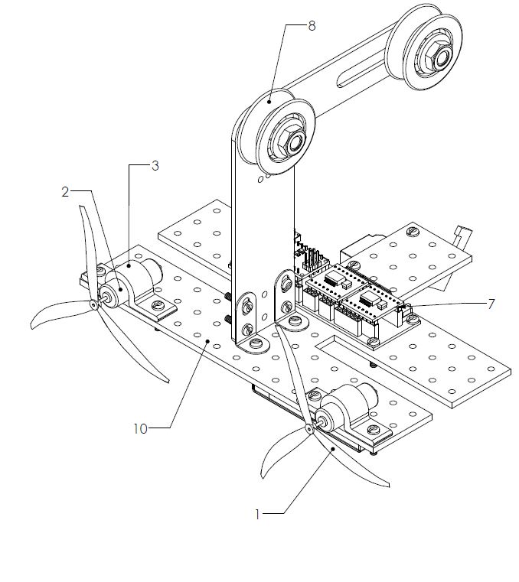

Engineering 1182

Tim Jacino

Andrew Kolibaba

Zach Sentivany

Tyler Sullivan

**Acknowledgements**

Tim Jacino………………………………………………………...Design Lead, Prototyping Specialist

Andrew Kolibaba………………………………………………...AEV Technician, Testing Engineer

Zach Sentivany…………………………………………………….Team Coordinator, CAD Specialist

Tyler Sullivan……………………………………….………….Electrical Engineer, Arduino Controller

**Table of Contents**

Executive Summary………………………………………………………………………………………3

Introduction………………………………………………………………………………………………..4

i. Background.…………………………………………………………………………………….4

ii. Purpose……………………………………………..…………………………………………...4

Results and Discussion………...……………………………………………………………….……….5

i. Description of Concepts ……………………………………………………………………....5

ii. Screening and Scoring Matrices ……………………………………………………………..9

iii. Observations from Testing………...…………………………………………………………14

iv. Cart Weight Observations………………………………………………………………..…..17

v. Discussion……….……………………………………………………………………………..21

Conclusion and Recommendations……………….…………………………………………………..23

Appendices…………………………………………………………………………………………….24

i. Schedule….…………………………………………………………………………………....24

ii. AEV Prints..…………………………………………………………………………………....25

iii. Excess Energy Charts………………………………………………....……………………..40

**Executive Summary**

The project design team was contracted by a national park entity to design a transportation system for visitors. This transportation system was to be designed around a monorail system that would tow a transportation carriage for visitors. The transportation system must have a focus on energy management, operational efficiency, and operational consistency. In order to achieve these requirements, the project design team created a mock vehicle that would represent a full scale vehicle and performed several different tests on the system to determine its compatibility with the contract requirements.

An Advanced Energy Vehicle (AEV) was chosen as a mock vehicle for testing a system for the monorail. This type of vehicle was chosen due to the inherent importance placed upon energy efficiency in the creation of the system which coincided with team objectives for the project. Different AEV designs were conceived and tested by team members until two separate designs remained, then the two designs were merged together.

Due to the complicated nature of the merged design, a final prototype was never fully conceived due to unforeseen events that transpired (a national state of emergency) and a separate design was subcontracted out to an independent design firm that provided the final design, known as the Pink AEV. The Pink AEV had satisfactory power usage per kilogram (449 Joules per kilogram) and initial testing was completed with the model as a result.

Further AEV experimentation was done with a transportation carriage in two different configurations, weighted and unweighted. The weighted carriage used 1034 Joules per kilogram while the unweighted carriage used 961 Joules per kilogram. The difference in Joules per kilogram between the weighted and unweighted cart was determined to not be significant, which contributed to an overall satisfactory evaluation of the Pink AEV. Further testing is required to determine the system’s operational consistency.

**Introduction**

The project design team was contracted by a national park organization to construct a monorail system for park transportation. This monorail system must consist of an advanced energy vehicle (AEV) that will tow a visitor transportation carriage. The client stipulated that the vehicle must be energy efficient, as electricity at the area of operation is limited. By extension, the vehicle must run on as little power as possible as to not strand visitors in a remote area. The vehicle must also perform multiple stops for an interval long enough to exchange visitors and allow suitable time increments for visitors to view local scenery.

With the client’s stipulations, the project design team tasked with the design of the AEV identified three primary focuses for this project.

* Energy Management
* Operational Efficiency
* Operational Consistency

Energy management is critical to not strand visitors. Operation efficiency is critical to minimize power usage, which is imperative to energy management. Operational consistency is critical to safety and power usage; the AEV should perform the same way regardless of cargo weight each time it runs.

The AEV must have a focus on safety, given that park visitors will be the transported cargo. Risk to human life is greater for this project due to inherent dangers of being suspended above ground. Due to track variations as a result of shifting geographical features the AEV must not be directly dependent on specific track features.

A model AEV must be produced that will reflect the final product of the project design team. The model AEV must focus on the same three objectives listed above and will be tested for energy used per mass. The model AEV must be capable of coming to a smooth, controlled stop on inclines and not slip on the track. The AEV must also be capable of forward and reverse operation.

**Results/Discussion**

**Conceptualization**

To begin the design process the project design team met to brainstorm ideas. The team collectively discussed aspects of the project that seemed to be of importance to the client and each member proposed their own ideas as to how the AEV design should be approached. A rudimentary AEV was constructed from a modelling kit and used as a jump off point for team members to experiment with their own part configurations to give a physical medium through which ideas could be proposed. Team members were tasked with creating an orthogonal sketch of their respective AEV ideas and proposing them to their team where a quick pros and cons list could be produced and adjustments could be made to solidify ideas.

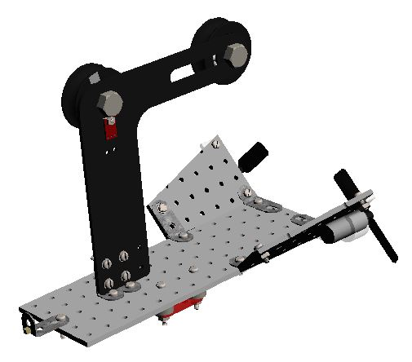

Figure 1. Sample AEV constructed by project team

The designs proposed by the team ranged from traditional to exotic by comparison of the sample AEV shown in Figure 1. The AEV shown was determined by the team to most likely be all around well performing. It was light, simple, and most likely energy efficient. However, the sample AEV was determined to be lacking features that would make it safe to operate.

The Sample AEV had two brushless motors which turned two 2-blade propellers. The sample AEV was constructed from one main panel and two slanted panels which would support the motors. The sample AEV would suspend itself from an L-shaped arm which would fix one pulley wheel with reflective tape and a pulley wheel without reflective tape to the arm, as well as two light reflectance sensors. The sample AEV housed its battery underneath the unit, which was clamped in place by four screws and a red fixture. The Arduino would be mounted directly below the pulley arm on the main panel.

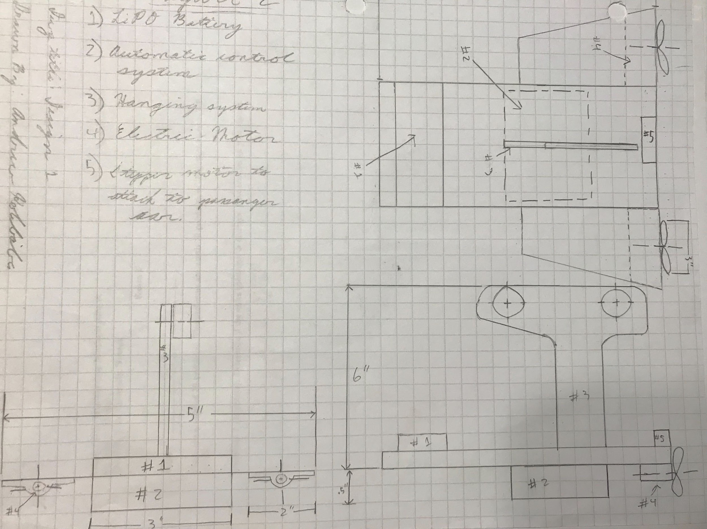

Figure 2. Andrew Kolibaba AEV Concept drawing

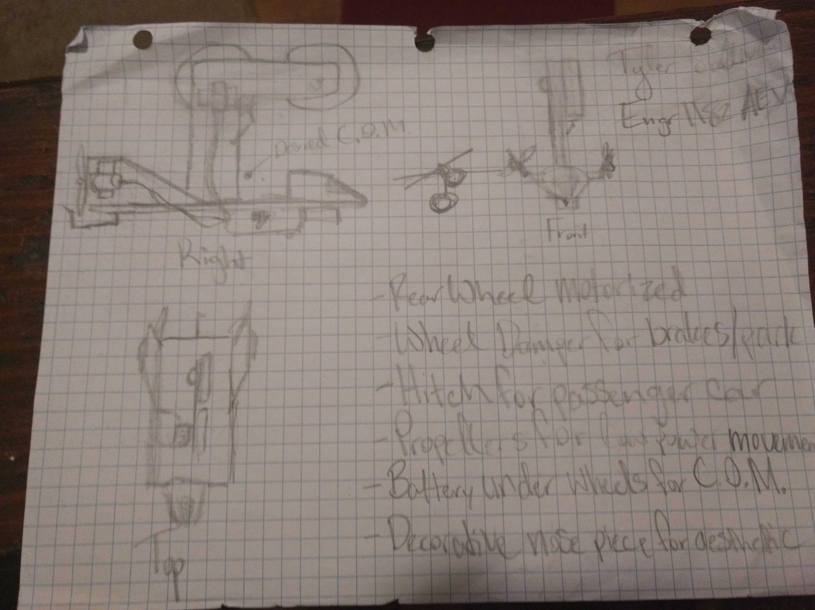

Figure 3. Tyler Sullivan AEV Concept drawing

Figure 2 and Figure 3 show two initial designs that deviated less from the sample AEV due to a desire for lesser weight and more simplistic featureless designs. A feature that was identified very early in the design process as being a desired design element was utilizing a drive wheel rather than propellers as a means of propulsion of the AEV. The design shown in Figure 2 changed the arm suspension system to an alternative model and relocated the Arduino and battery features while choosing to retain the propeller mode of propulsion. The design in Figure 3 made the first leap into custom fabricated parts by proposing a motorized rear wheel as discussed formerly. This design also featured a wheel damper for breaks and parking maneuvers. This vehicle also featured propellers for usage in low energy demanding scenarios and a rudimentary hitch mechanism for towing the cart.

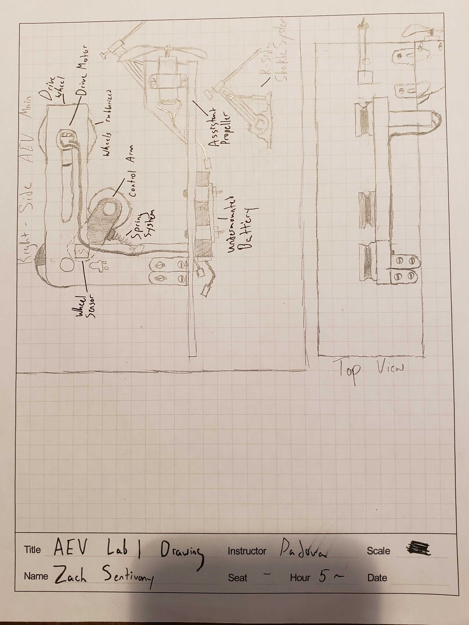

Figure 4. Zach Sentivany AEV Concept drawing

Figure 4 represents another evolution in the design process. This design further embraced the drive wheel concept and expanded upon it, by eliminating one propeller that would be used only for turning maneuvers. This AEV also featured a wheel mounted on a control arm that would perform a clamping action for the rail via spring, in effect sandwiching the rail between the upper pulley wheels and the lower pulley wheel, which would all be rubberized to lower the need for a braking mechanism.

Many of these concepts would be compressed into a more neat package with the introduction of the final (and ultimately accepted) design concept shown in Figure 5. This design stepped far outside of the bounds of the sample kit in which the team had been using to this point and instead proposed almost entirely fabricated parts to implement. This design was compact and demanded less space to do more than other designs. The design featured only a drive wheel for track mobility and utilized two suspension arms to keep the AEV clamped to the track as it moved along.

Due to the compacted design, this AEV would require less energy to traverse the track, the drive wheel will use less energy than utilizing two propellers, and having the torque advantage of a rubberized wheel on the track will allow for operational consistency under different loads. This design met all of the client’s criteria and the team chose to move forward with this design and the design from Figure 4.

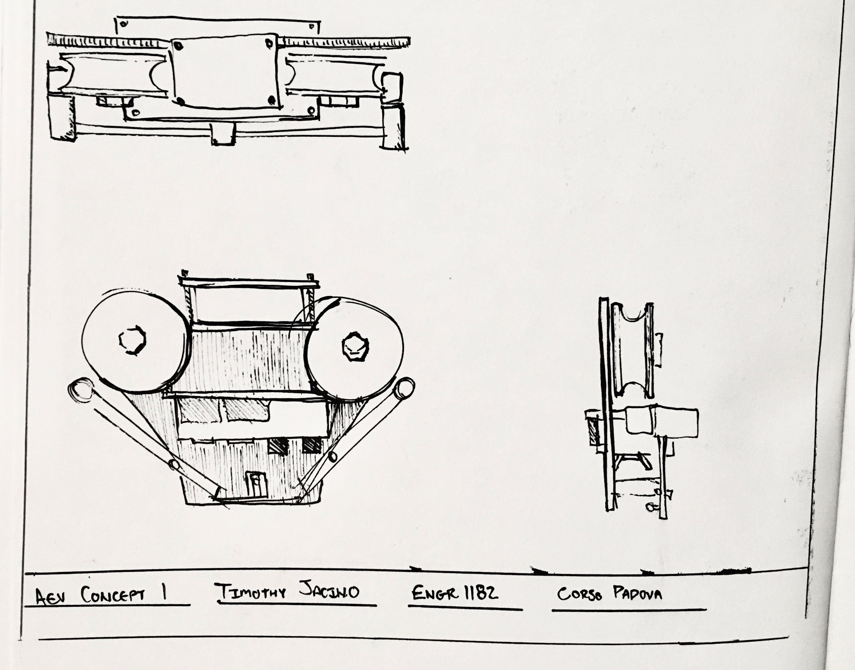

Figure 5. Tim Jacino AEV Concept Drawing

While the design from Figure 5 did meet the client’s criteria, it did have its drawbacks. The design required almost entirely custom fabricated parts, making it more costly to assemble than other designs which used standard production parts. This also increased the time it would take to manufacture the AEV as well, leading to an elongated prototyping phase of the project. The design from Figure 4 was a median between the exotic design of Figure 5 and designs of Figure 2 and Figure 3. It embraced custom parts but still used many readily available production components as well.

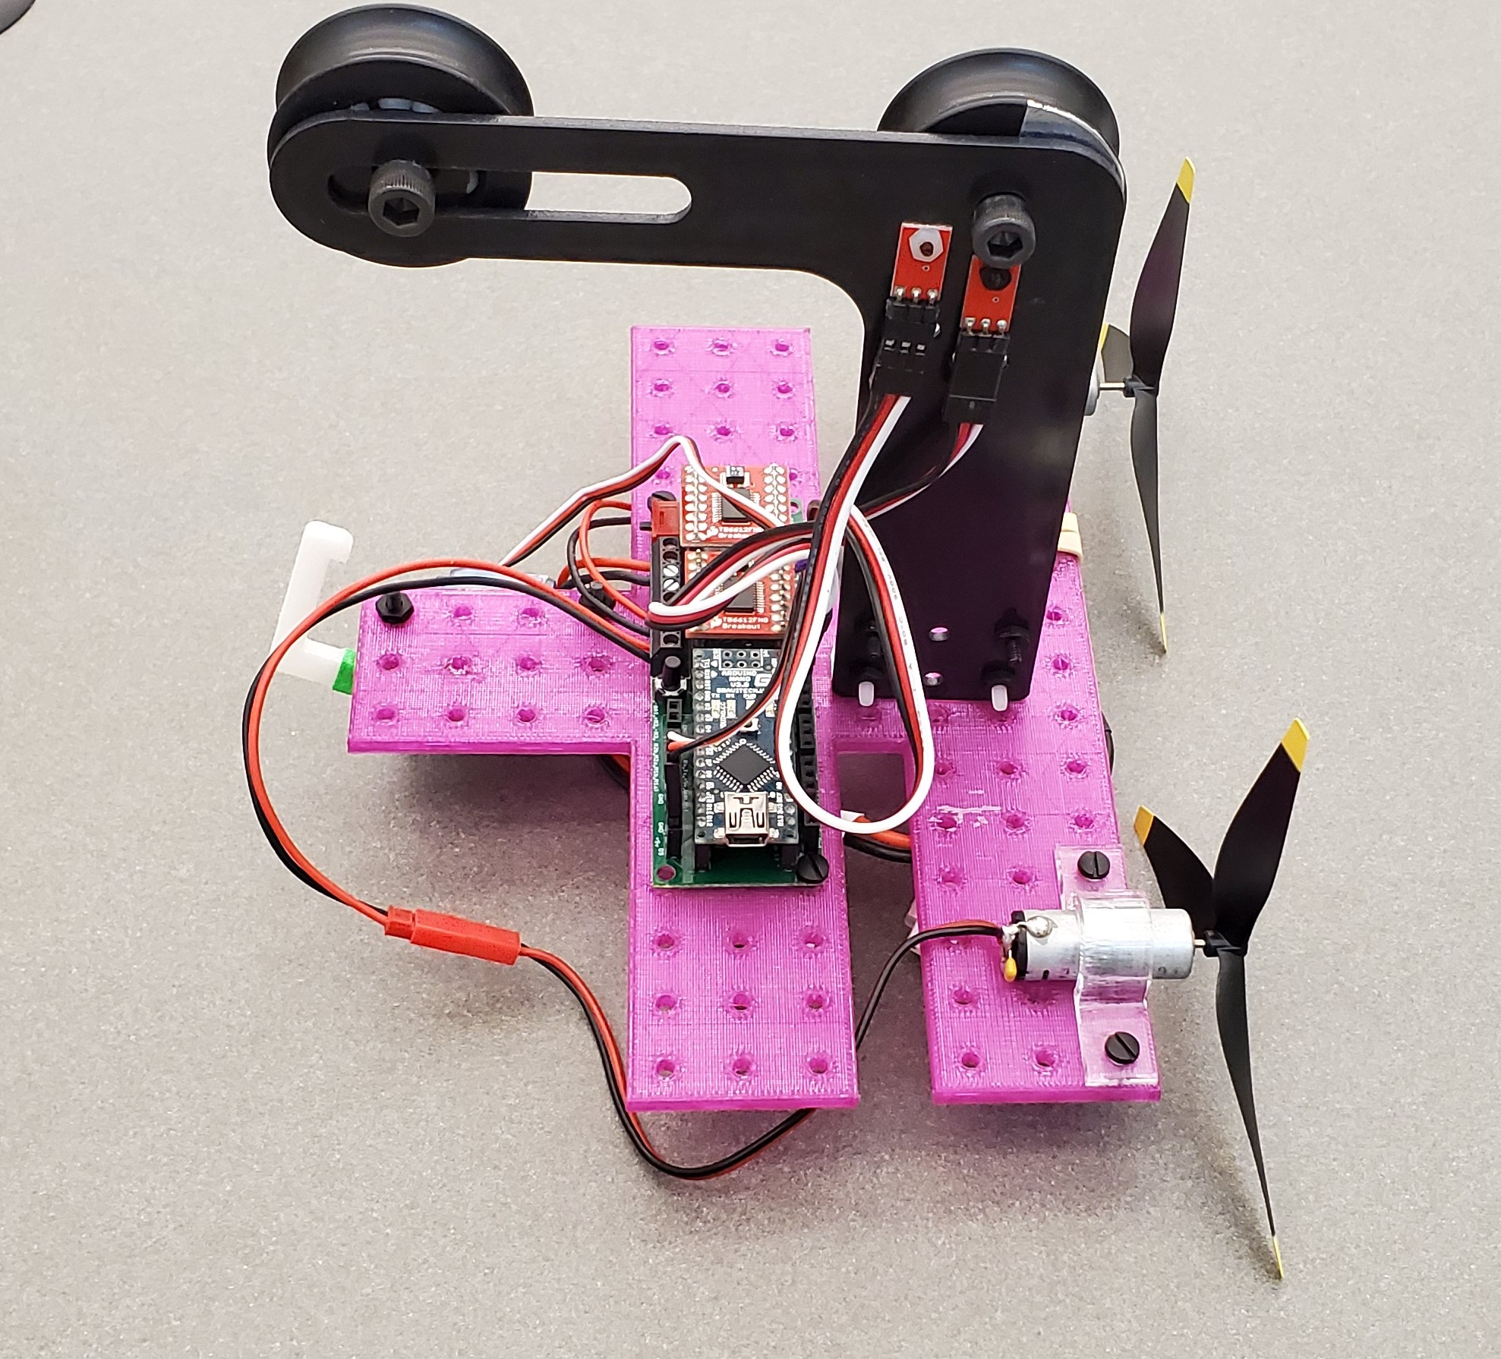

Figure 6. Subcontractor AEV submission

As an unforeseen consequence of a recent international state of emergency, aspects of the AEV design had to be delegated to an independent subcontractor in lieu of a total contract suspension, who submitted the Pink AEV design shown in Figure 6. The Pink AEV would ultimately be the design chosen by the project design team to submit to the client.

**Concept Screening and Scoring**

In order to more accurately define the characteristics that were desired in the vehicle, the team moved forward from the brainstorming phase and into the scoring and screening phase of the design process. This involved identifying success criteria for the AEV that would be used to determine how conceptually strong an idea was.

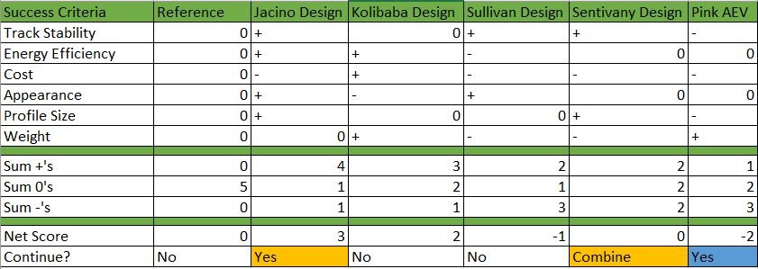

Table 1. Concept Screening Matrix

Table 1 displays all success criteria that was used to determine how to proceed forward with an individual design. Track stability was chosen for its importance to safety and operational consistency. Energy efficiency was used for its importance on operational efficiency and energy management. Cost was chosen in order to find a design that could be provided to the client for the lowest possible cost of manufacturing. Appearance was chosen for cosmetic purposes; the AEV is a commercial vehicle where an appealing appearance would be beneficial. Profile size for it’s importance on track stability where having a smaller profile would be beneficial rather than a larger and more unwieldy design. Weight, due to the overall importance that it plays on track stability, energy efficiency, and the three overarching success criteria outlined in the mission goals.

The screening matrix was not used as a deciding factor for which AEV to move forward with, but rather how to modify favored designs during development. The reference AEV was determined to be the baseline for which all designs would be compared against.

The Jacino design (seen in Figure 5) performed well in initial screening. The compact design that enclosed and clamped itself around the monorail offered favorable predictions. Due to only needing one motor for the design it scored well in energy efficiency as well. However, an inflated manufacturing cost prevented it from performing well in the Cost category. The compact design lends itself to a better profile size in relation to the reference AEV as well. While the Jacino design was smaller than the reference AEV it was more feature heavy, which caused the initial design to be roughly the same weight as the larger reference AEV.

The Kolibaba design (seen in Figure 2) did well against the reference AEV in the concept screening feature wise. Due to its similarity against the reference AEV the design it received the same score in both track stability and profile size. The lighter, less feature heavy Kolibaba design resulted in favorable marks in energy efficiency as a consequence of a lighter vehicle, cost for its use of less parts while remaining stock, and weight for it’s more featureless design. However due a more bland appearance the design received less than favorable marks in appearance.

The Sullivan design (seen in Figure 3) was the first AEV to receive a lower score than the reference AEV. The Sullivan design performed better conceptually than the reference AEV on the criteria of track stability from the brake dampener system and appearance from the use of an aesthetic piece. The beneficial areas lent themselves to negative areas of the design as well. Due to the additional weight of the features implemented in the design, the Sullivan design suffered in the areas of energy efficiency, cost, and weight. The Sullivan design received neutral marks in profile size due to its similarity to the original design.

The Sentivany design (seen in Figure 4) received a neutral score on the screening matrix. The AEV scored well in track stability for its use of a clamping suspension arm and in the area of profile size for it’s smaller silhouette in comparison to the reference AEV design. Due to the extra features of this design adding extra weight and requiring custom manufacturing this design received negative marks in the cost and weight fields. The Sentivany design was determined to be neutral in regards to the reference AEV in appearance as no visually appealing elements were addressed. The Sentivany AEV was also neutral in terms of energy efficiency; while the design was heavier it made use of a more energy efficient system.

The Pink AEV (seen in Figure 6) received overall unfavorable marks on the concept screening matrix in comparison to the reference AEV. An area in which the pink AEV excelled was in the area of weight. The pink AEV had a custom manufactured base, which reduced the amount of fasteners required to assemble the parts together. While the Pink AEV was of a lesser weight than the reference AEV conceptually, it was very similar in other aspects. Due to having a similar propulsion system as the reference AEV it scored neutral marks in terms of energy efficiency. The appearance was not addressed more in the Pink AEV, lending itself to neutral marks in that area. Due to having a very large unwieldy base, the Pink AEV scored negative marks in track stability and profile size. Due to also requiring custom manufactured parts the Pink AEV also scored negative in the cost category as well.

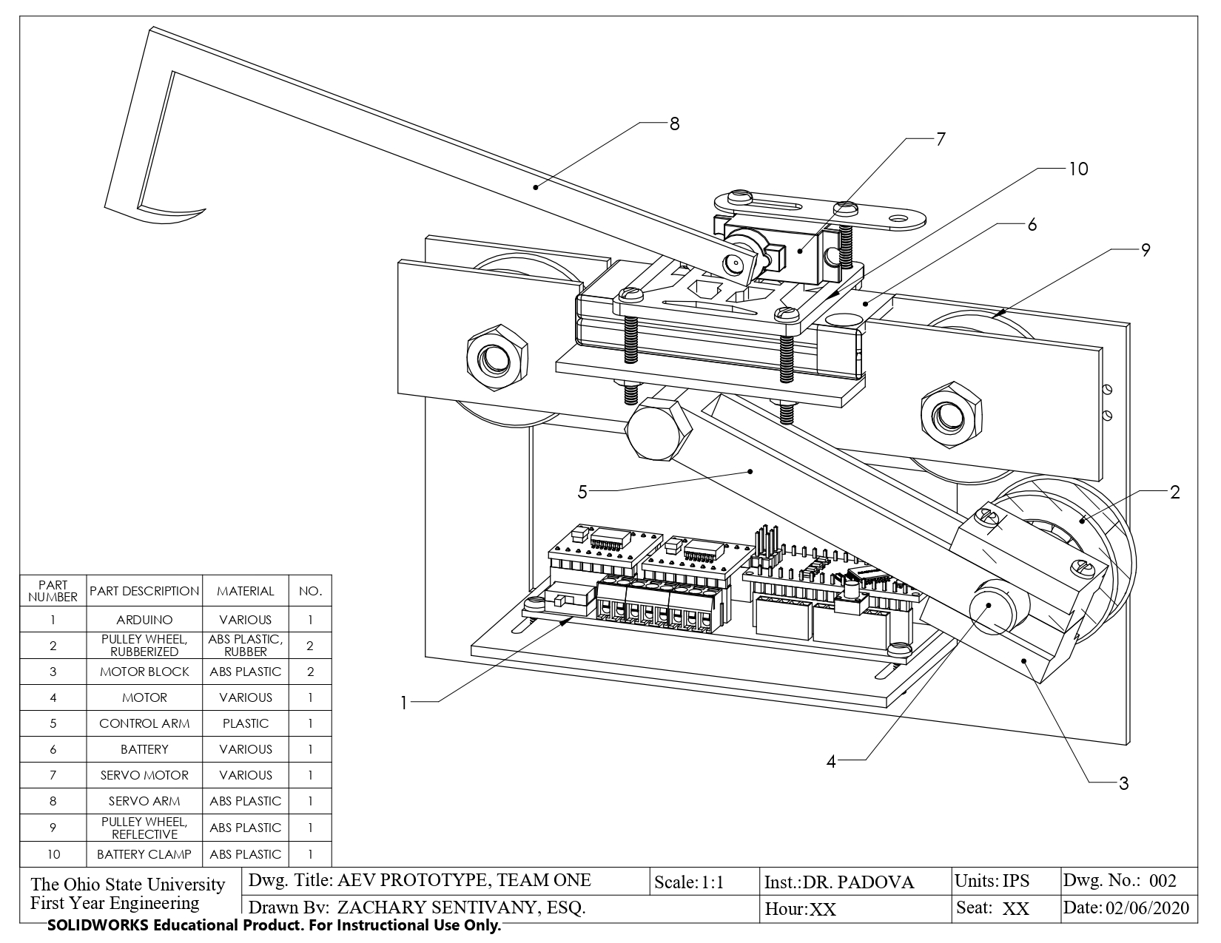

Figure 7. Jacino-Sentivany Super AEV Print, Approximate Weight 310 g

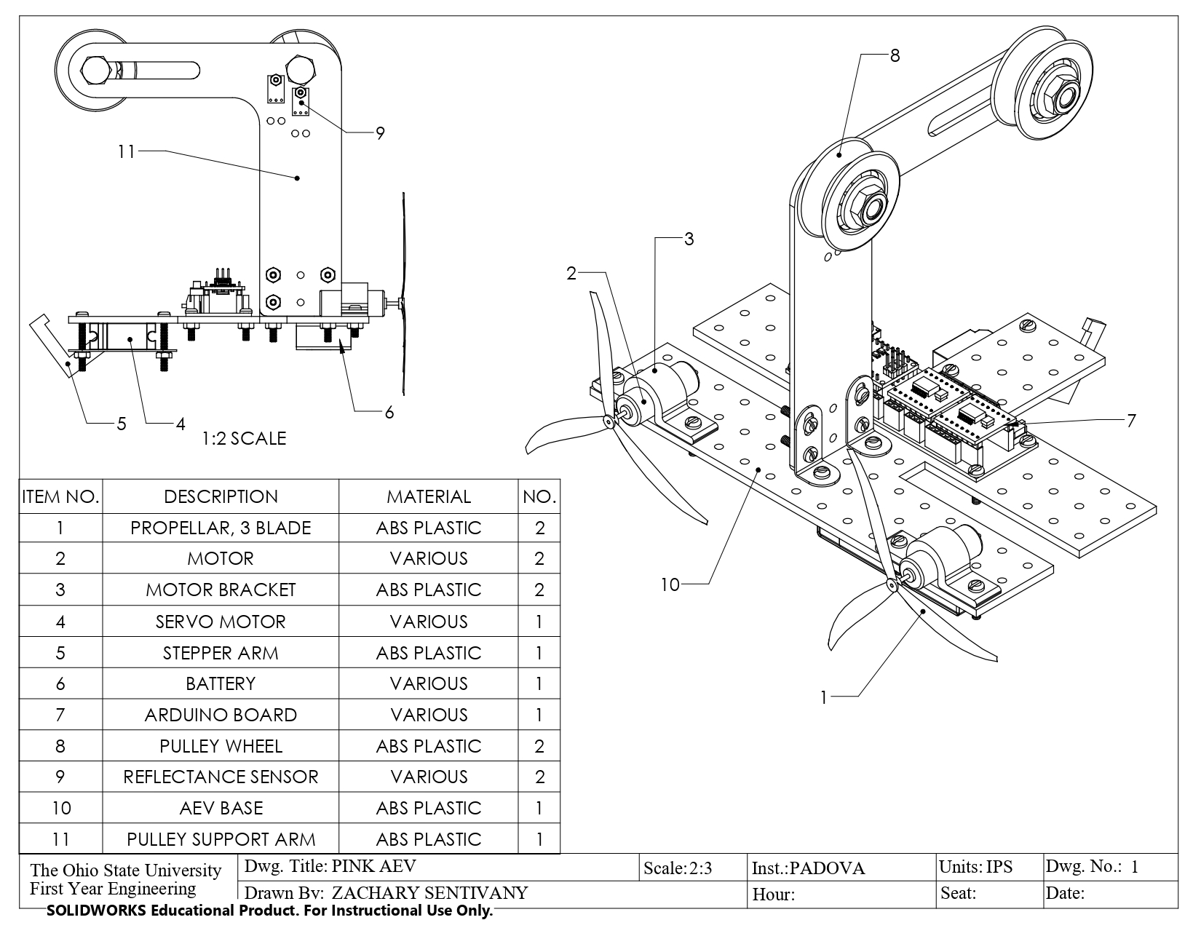

Figure 8. Pink AEV Print, Approximate Weight 268 g

After initial analysis of the five designs, the team moved to combine aspects of the Sentivany design into the Jacino design (Figure 7) and move forward with it as well as the Pink AEV (Figure 8). As the next step of the conceptualization phase, the team created a concept scoring matrix which better outlined the weight of each of the success criteria in the decision making process. Track stability and energy efficiency were determined to be the most heavily weighted criteria due to their close relation to the mission objectives, followed closely by cost for its importance on securing the contract. Weight, profile size, and appearance were determined to be of lesser importance conceptually. All criteria were rated on a scale of 1-5 and then multiplied by the weight of each category. Each score was then added up for a maximum possible total score of 5 and a lowest possible total score of 1.

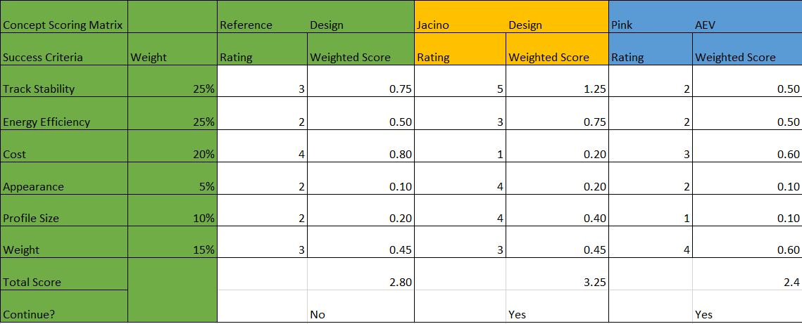

Table 2. Concept Scoring Matrix

The reference AEV sensibly scored close to a 2.5 on the scoring matrix (Table 2), reflecting that the reference AEV was an acceptable average point conceptually. The reference AEV scored above average on cost due to its simplistic construction and reliance on readily available parts. The AEV scored below average on energy efficiency, appearance, and profile size.

The Jacino-Sentivany design scored above average total with a score of 3.25. The design received high marks in track stability for its use of a clamping suspension arm and rubberized wheels, appearance due to being an aesthetically pleasing design, and profile size as a result of its compact design. The Jacino-Sentivany design performed average in weight and energy efficiency, and poorly in cost, receiving the lowest possible score in the category due to the highly custom design with an inflated manufacturing cost.

The Pink AEV performed poorly compared to the two other designs, but average overall. The Pink AEV was given favorable scores in cost and weight. Cost was favorable, but still lesser than the original AEV which featured no custom parts. The weight was scored very high as a result of being a lesser weight than the reference AEV. The Pink AEV performed poorly in track stability, energy efficiency, and appearance. The AEV received these scores in energy efficiency and appearance as a result of conceptual similarity to the reference AEV. The Pink AEV’s poor scoring in track stability is a result of its large and unwieldy design, which also contributed to the design's lowest possible score in profile size.

The team originally planned to move the Jacino-Sentivany design into the next design phase, however, due to issues explained above, moved forward with prototype testing for the Pink AEV.

**Observations From Testing**

The project design team took to designing the code that the AEV would operate under. While the Jacino-Sentivany design was being constructed a temporary AEV design was used to test different coding configurations with a propeller configuration rather than a drive wheel configuration. Initial testing was performed in small increments on a test track similar to the one illustrated in Figure 9.

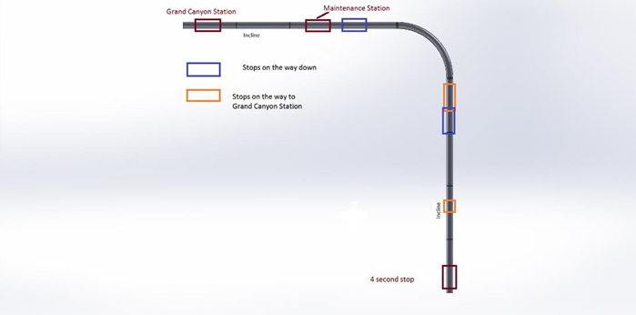

Figure 9. Test Track Layout

Testing required fine tuning the machine code the Arduino board would read. Suggested code was provided by project management, then optimized. A GUI was used to upload code segments into the Arduino board, then the AEV was placed onto the track and the code was allowed to run. Team members observed the behavior of the AEV and adjusted the code based on the performance of each run. Initial testing was done using static commands rather than relative position-based commands, however, later code iterations made use of the coding techniques.

Several tests were required to optimize code and were done over half of the track rather than the whole track. Early testing resulted in erratic AEV behavior which was culled by gradual code modification from team members. The original accepted code for the test AEV in the propeller configuration was most likely comparable to the provided Pink AEV code. The test AEV was lighter in weight than the Pink AEV, but code could be easily modified to facilitate the heavier weight of the Pink AEV by adjusting power levels within the code configuration. As a result, the Pink AEV would likely have higher power consumption and a lower power efficiency rating. While the Pink AEV is non-ideal in some areas, it will be able to perform the mission requirements in a satisfactory manner.

A MATLAB program was created to interpret data collected by the Arduino board over the course of the run. This data was used to analyze how energy was consumed over time and distance during a run, as well being used to calculate various other factors such as advance ratio and propulsion efficiency. Data collected from the most satisfactory Pink AEV half track run is compiled below. Note, the AEV does not have its carriage attached. Due to missing test data for the Jacino-Sentivany test AEV design, a direct comparison is not possible.

As can be seen in Figure 10, outside of chatter at advance ratio value 0.15 (that is a result of a data filter) the propulsion efficiency increases in a linear fashion as advance ratio increases. In Figure 11 there are well defined sections of the chart where power increases, decreases, and goes steady. These sections define where certain code begins and ends. Because the code was time dependent in most places, team members were able to plot power usage as a function of time, then use the increases, decreases, and flats of the chart to identify phases of the code (as can be seen in Figure 12, and defined in Table 3).

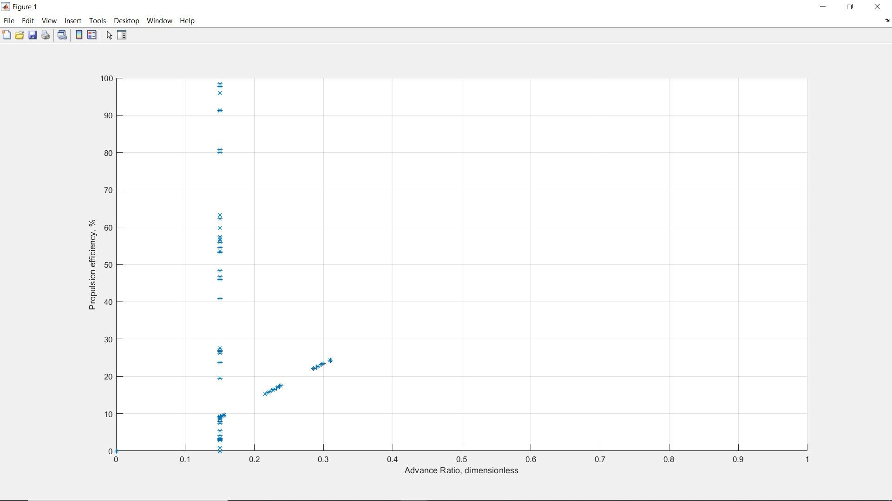

Figure 10. System Efficiency Versus Advance Ratio, Pink AEV, Half Run

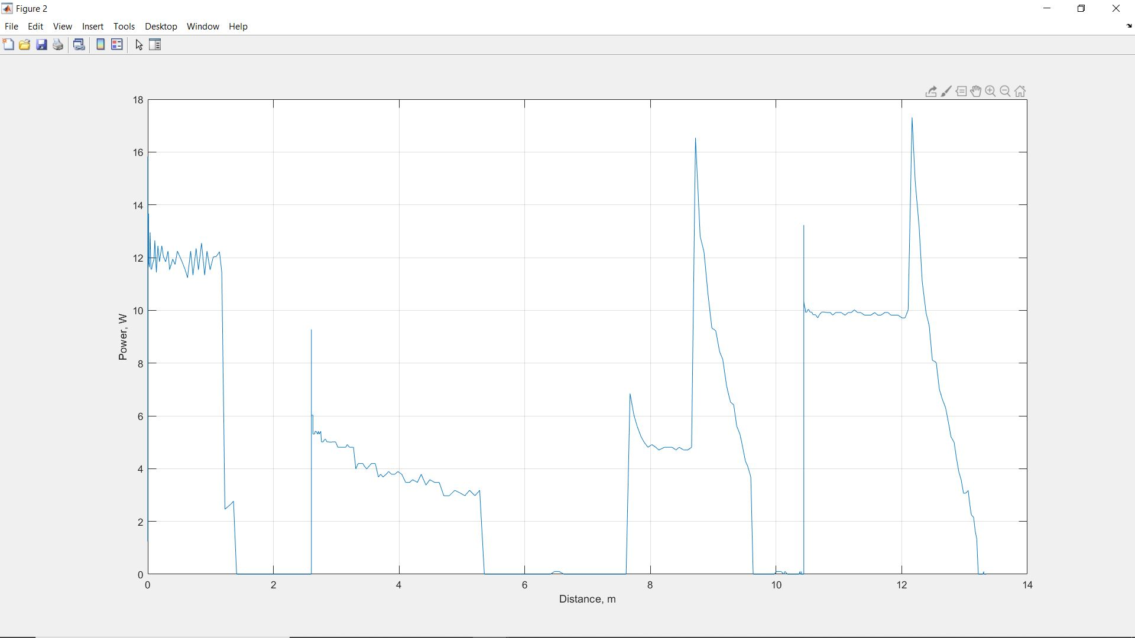

Figure 11. Power Versus Distance, Pink AEV, Half Run

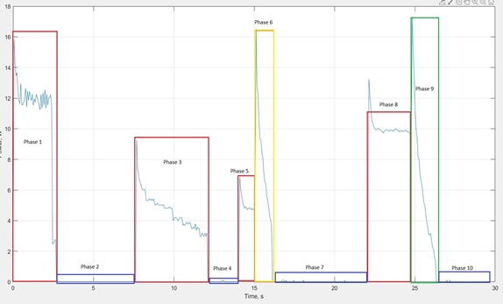

Figure 12. Power Versus Time, Pink AEV, Half Run, Phase Defined

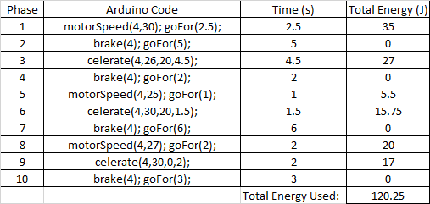

Table 3. Phase breakdown, Power Versus Time, Pink AEV, Half Run, 449 J/kg

Upon completion of the code testing phase of half track testing, the team moved on to testing the Pink AEV across the full track. This stipulated that the Pink AEV must start at a station, move to one end of the track and hitch itself to the transportation carriage, then transport the carriage to several stations along the track. In order for the AEV to hitch itself to the carriage, it must approach the transportation carriage and engage the servo motor which will lower an arm into a round hitch which can be seen in Figure 13.

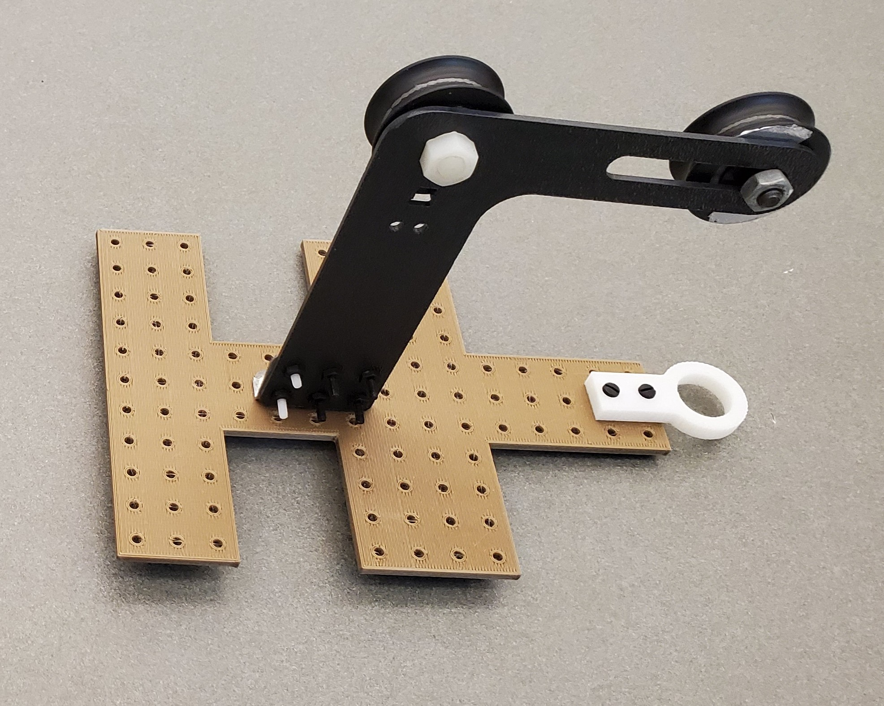

Figure 13. Transportation cart, unweighted, 112g

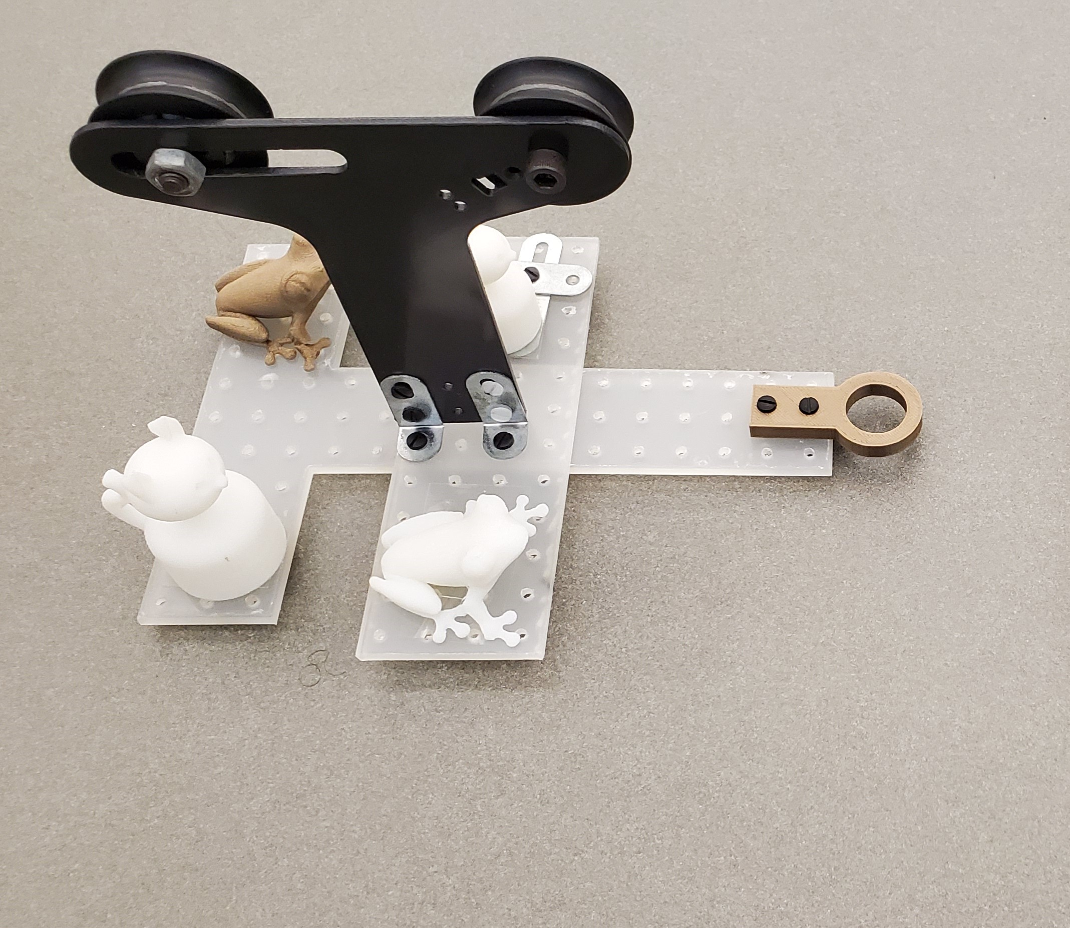

Figure 14. Transportation cart, weighted, 170g

The Pink AEV’s hitching arm could reliably hitch into the test carriage and should not inhibit track mobility in any way during maneuvers. Only a small amount of code modification should be required to facilitate the hitching mechanism lowering into the hitch ring. The AEV would need to jog to a predetermined location, engage brakes, run the servo motor for an amount of time, then the hitch would be engaged and the AEV can proceed onward down the track with the cart.

The AEV was tested in the same code configuration with two separate carts. The unweighted cart in Figure 13 and the weighted cart in Figure 14 were used to simulate the transportation carriage when it was occupied by visitors and unoccupied by visitors. Energy usage as a function of distance is shown in Figure 15 that shows a direct comparison between the two weight variations of the carts. The weighted cart predictably had a noticeably larger energy usage than the unweighted cart. Data gathered from the arduino board from each run was gathered and analyzed through the purpose built MATLAB program used in prior testing. Figure 16 and Table 4 correspond to data analysis of the unweighted cart runs. Figure 17 and Table 5 correspond to data analysis of the weighted run.

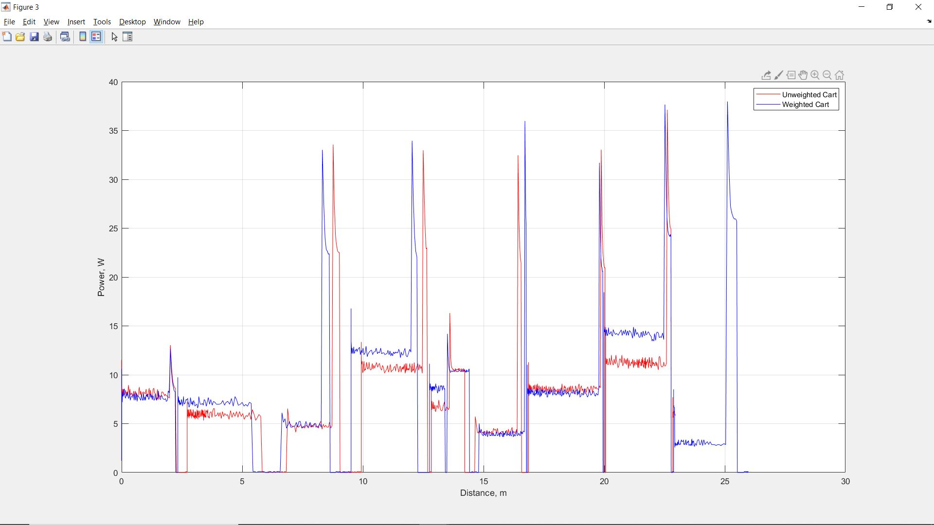

Figure 15. Power Versus Distance, Weight Comparison View, Full Run

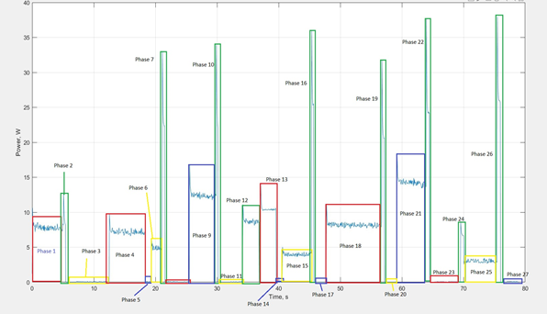

Figure 16. Power Versus Time, Pink AEV, Unweighted Cart, Full Run, Phase Defined

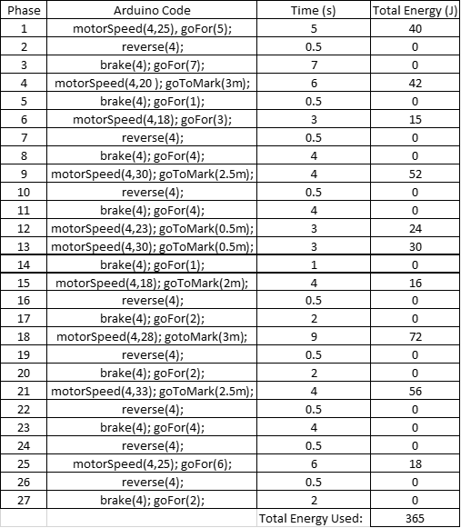

Table 4. Phase breakdown, Power Versus Time, Pink AEV, Unweighted Cart, Full Run, 961 J/kg

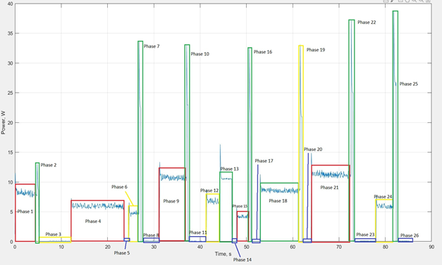

Figure 17. Power Versus Time, Pink AEV, Weighted Cart, Full Run, Phase Defined

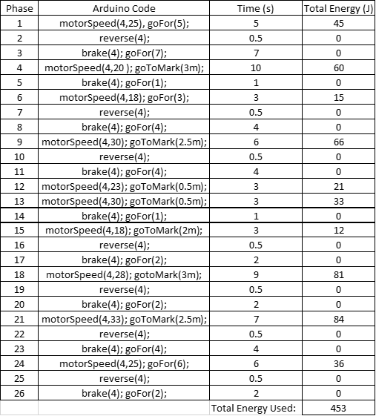

Table 5. Phase breakdown, Power Versus Time, Pink AEV, Weighted Cart, Full Run, 1034 J/kg

The difference in power usage seen in Figure 15 is echoed by the corresponding tables of each run. Table 4 indicates that the unweighted cart utilized 961 J/kg while the weighted cart data shown in Table 5 indicates that the weighted cart utilized 1034 J/kg. This difference in energy could be reduced by reducing runtime in the code where the AEV will have natural inertia from moving down an incline on the track. Utilizing the natural velocity of the AEV and disabling power to all motors would afford a lower power usage that may reduce the increased power usage of the AEV with a weighted cart.

**Discussion**

While there is a degree of uncertainty due to current limitations, some inferences may be made about the performance of the Pink AEV based upon logic. On final runs the AEV most likely behaved in a more sluggish manner with the weighted cart versus the unweighted cart. Also, the additional weight could cause track instability around high speed turns. There was also likely some difficulty optimizing the location of the AEV during a hitching maneuver during initial testing. The inclined stop was most likely a challenge to implement. Situational coding would be necessary due to the AEV needing to be adaptable to the different cart weight. A function would be necessary that increased or decreased motor speed based upon movement of the AEV upon the incline, that it must perform for a given amount of time once in the correct location.

The implications these tests have on a full-size monorail vehicle are yet to be seen. The square-cube law implies that a full-size model will be much heavier proportionally than the current AEV model, which will lead to lessened performance figures in testing of a full-size prototype. Careful selection of materials will be necessary for a full-size model, as weight will be a controlling factor for its importance to the three primary objectives of this project. As stated previously more testing is required.

**Conclusions and Recommendations**

The project design team’s mission was to deliver a model AEV to the client that would represent a large-scale monorail project. The AEV was to have a focus on energy management and operational consistency/safety. Though the team’s design went to the wayside due to unforeseen events transpiring, a small subcontractor was hired to handle later design implementation.

Subcontractor AEV performed below average conceptually, but within desired expectations delivering a satisfactory product. The Pink AEV consumed 961 joules per kilogram while unweighted and 1034 joules per kilogram while weighted, overall resulting in a satisfactory difference in energy use between the two configurations.

* Overall power usage was low, which satisfies client expectation of energy management.
* AEV power consumption did not fluctuate heavily between weighted and unweighted carts, which satisfies client expectations of operational efficiency.
* Further testing is required to determine if this AEV satisfies client operational consistency expectations.

More extensive testing is required with a wider load range on the AEV to determine operational consistency over time and to further investigate the effect of a variable load on power consumption.

**Appendices**

**Schedule**

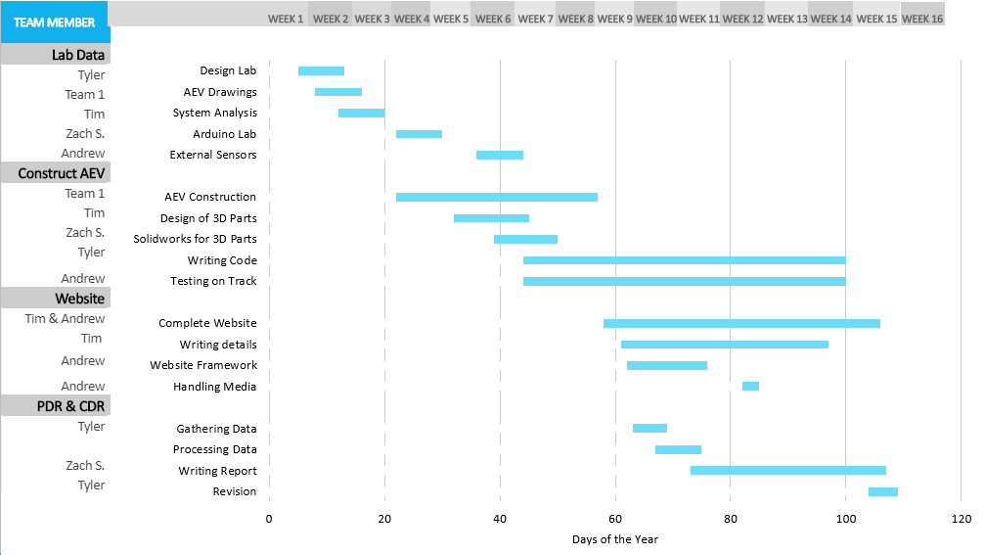

Figure 18. Gantt Chart Schedule

**AEV Prints**



Figure 19. Main AEV Drawing, 268g Weight

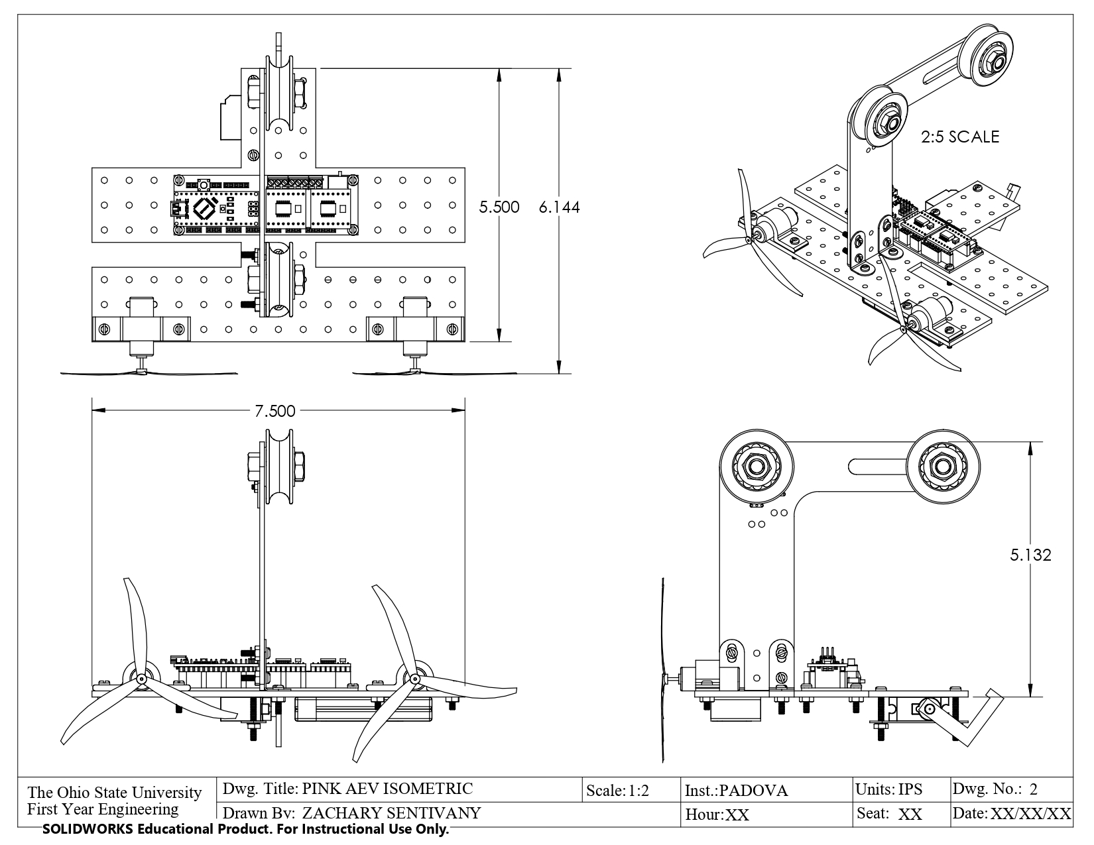

Figure 20. Main AEV Isometric

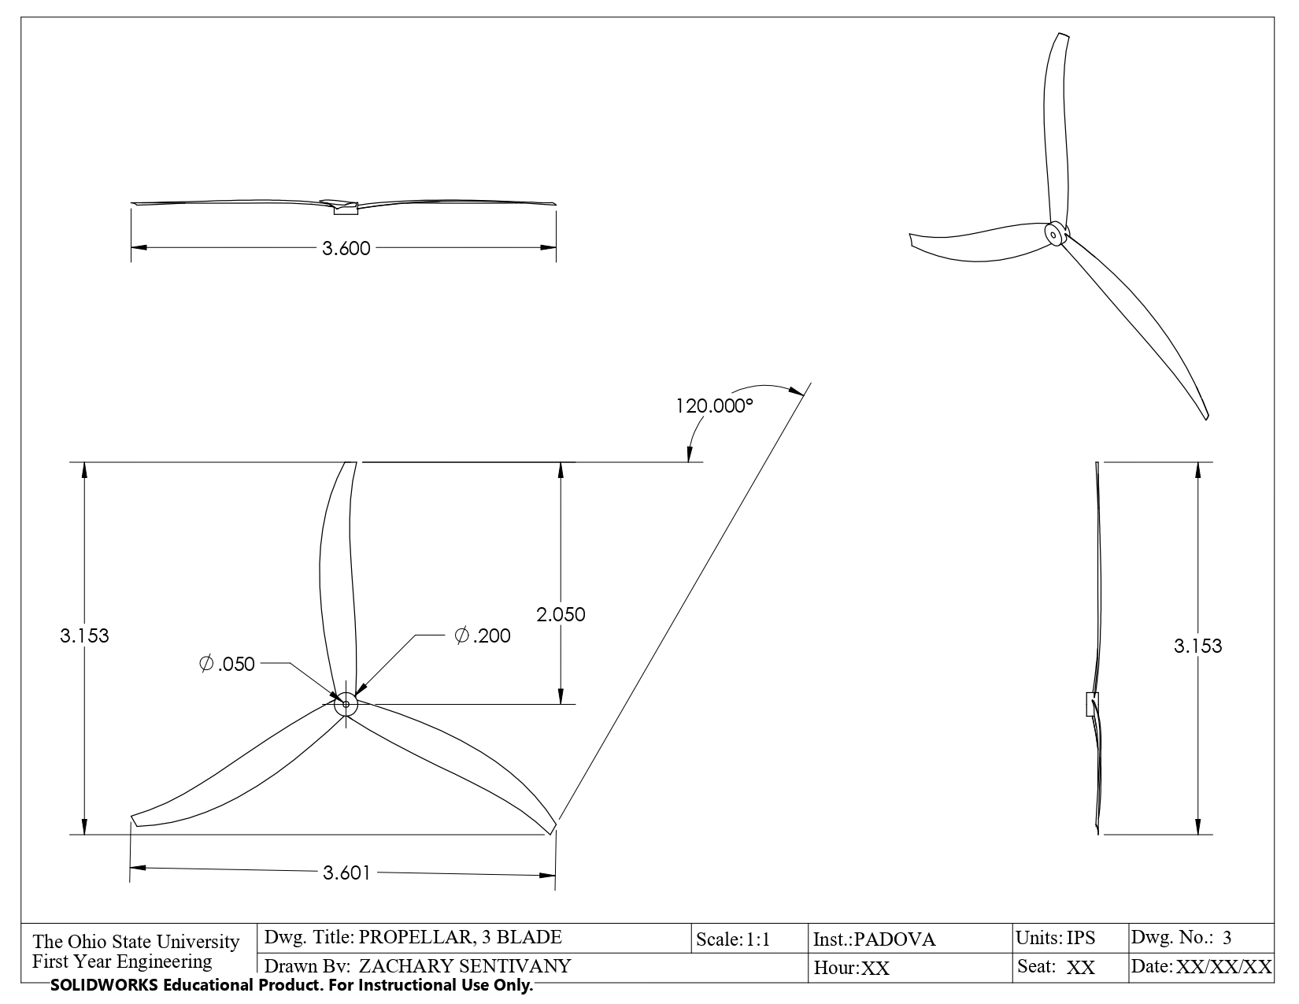

Figure 21. Three Blade Propeller Isometric

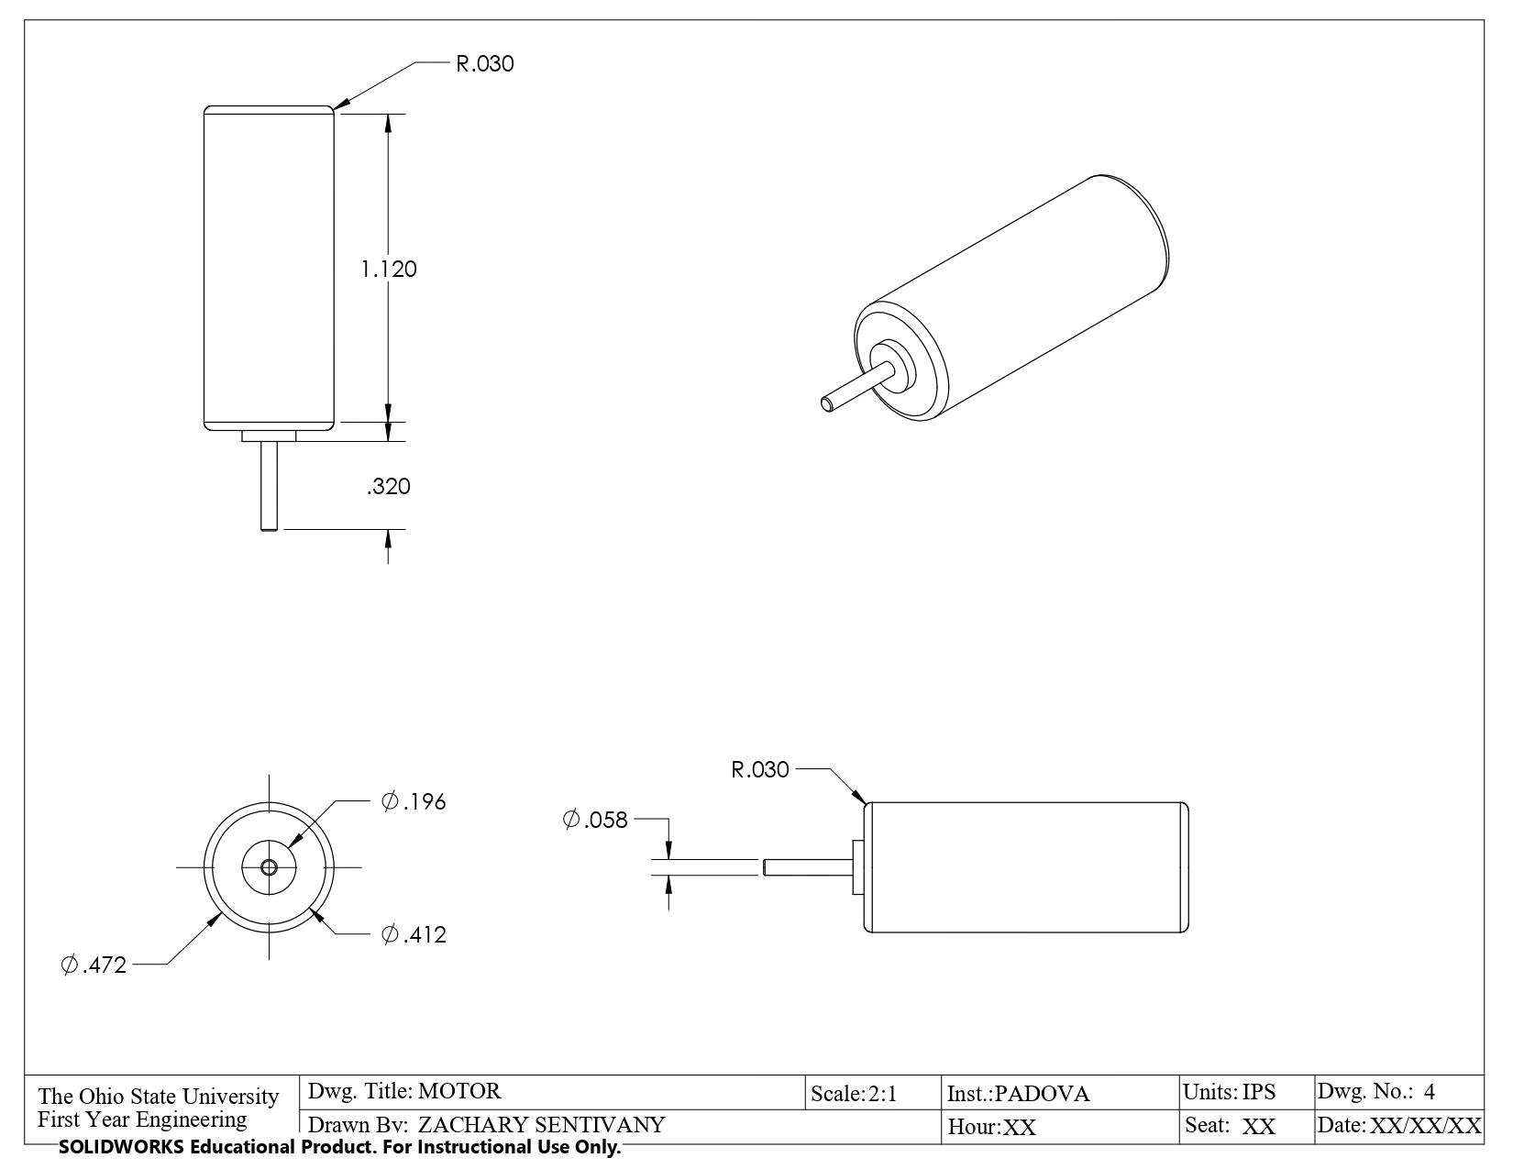

Figure 23. Motor Isometric

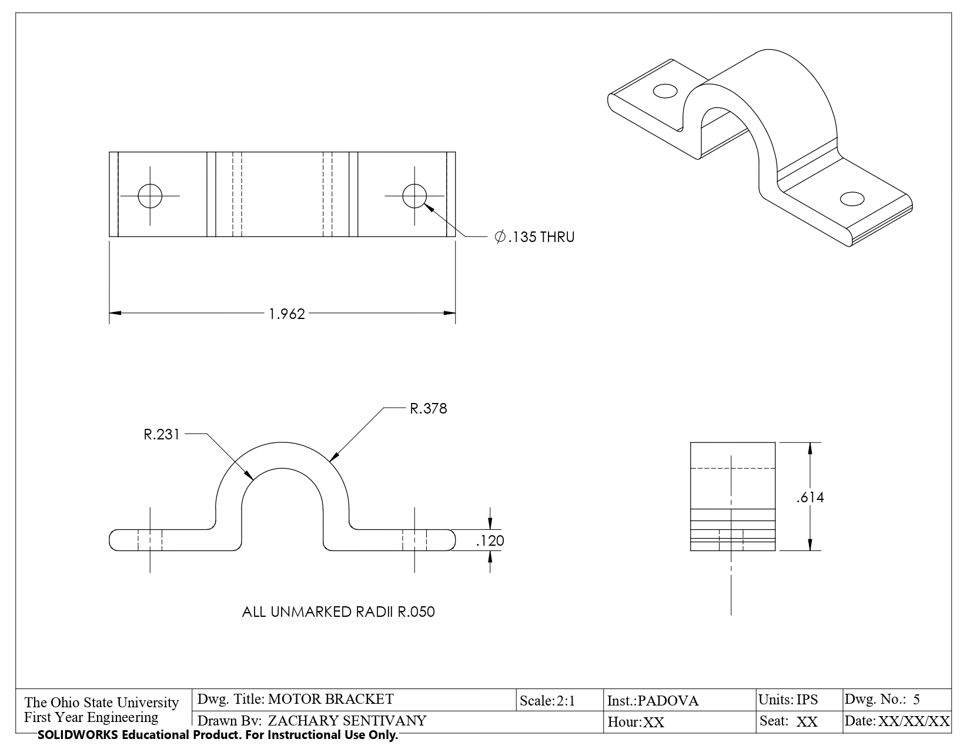

Figure 24. Motor Bracket for AEV Motor

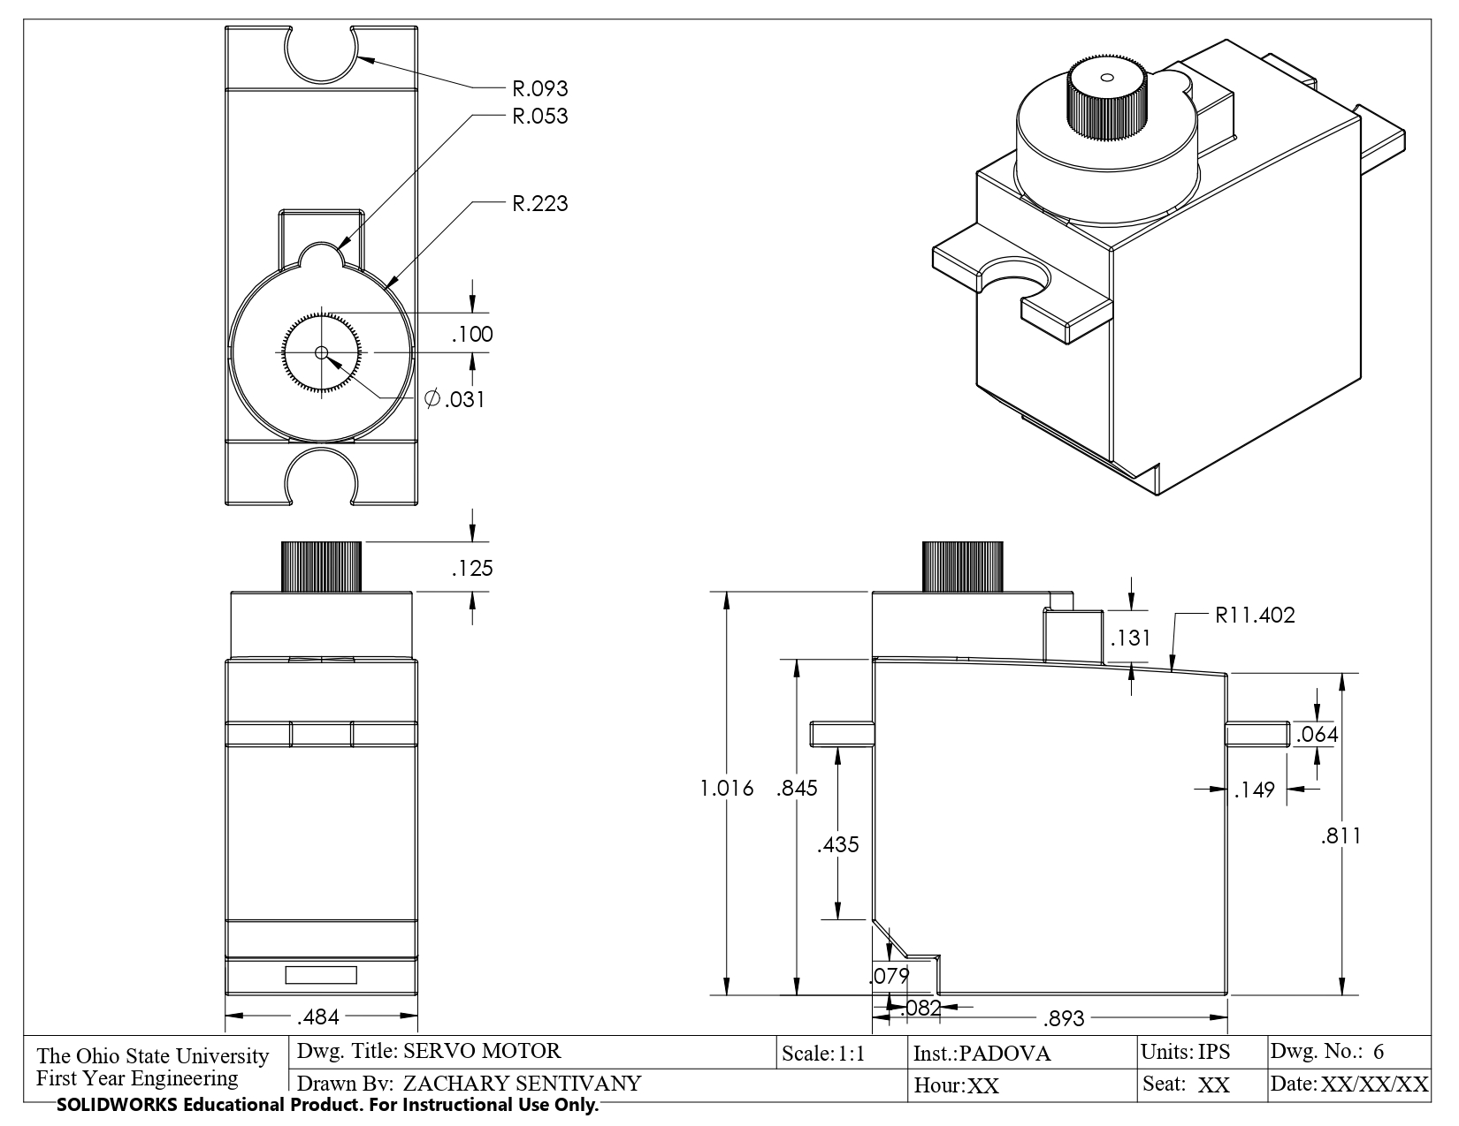

Figure 25. Servo Motor for Hitch Assembly

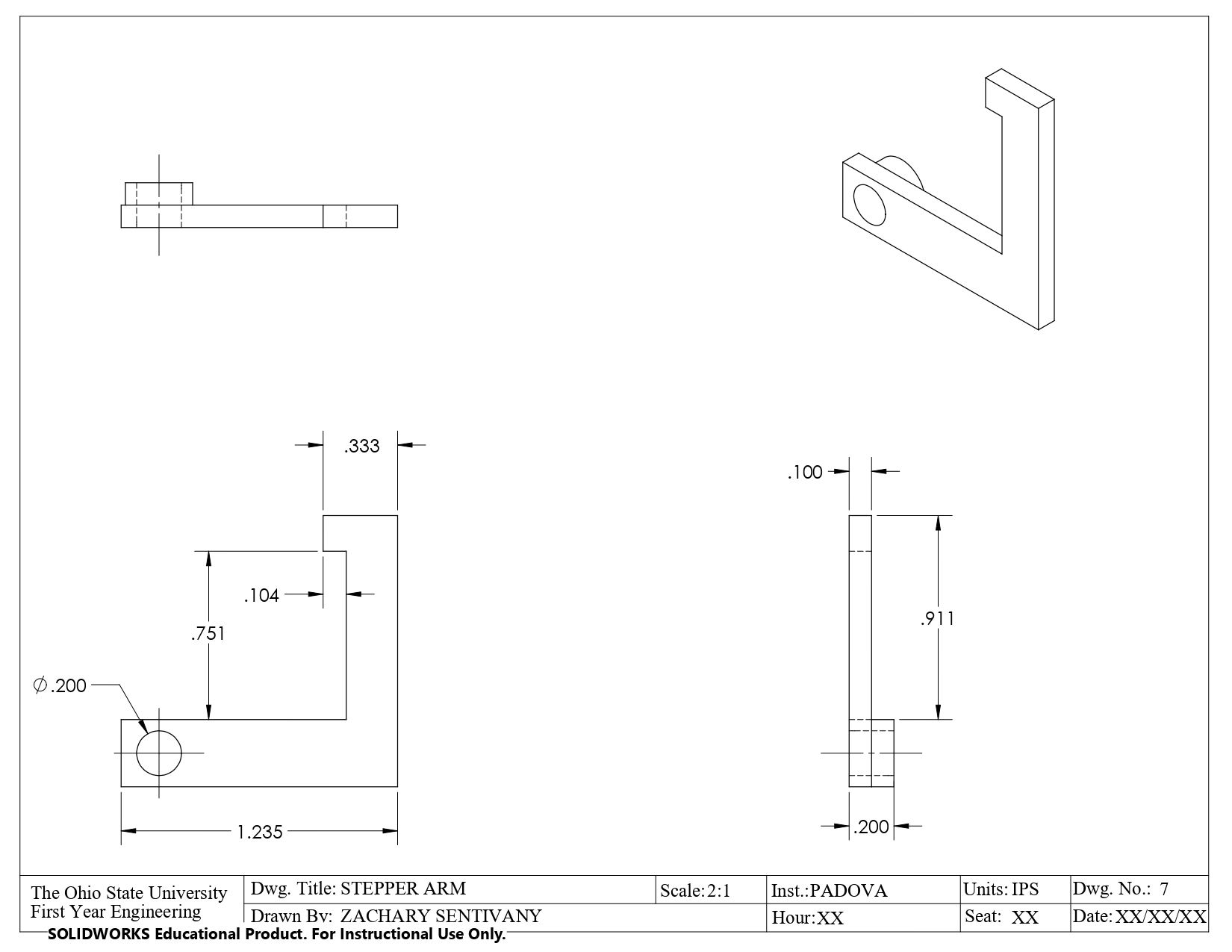

Figure 26. Stepper Arm for Hitch Assembly

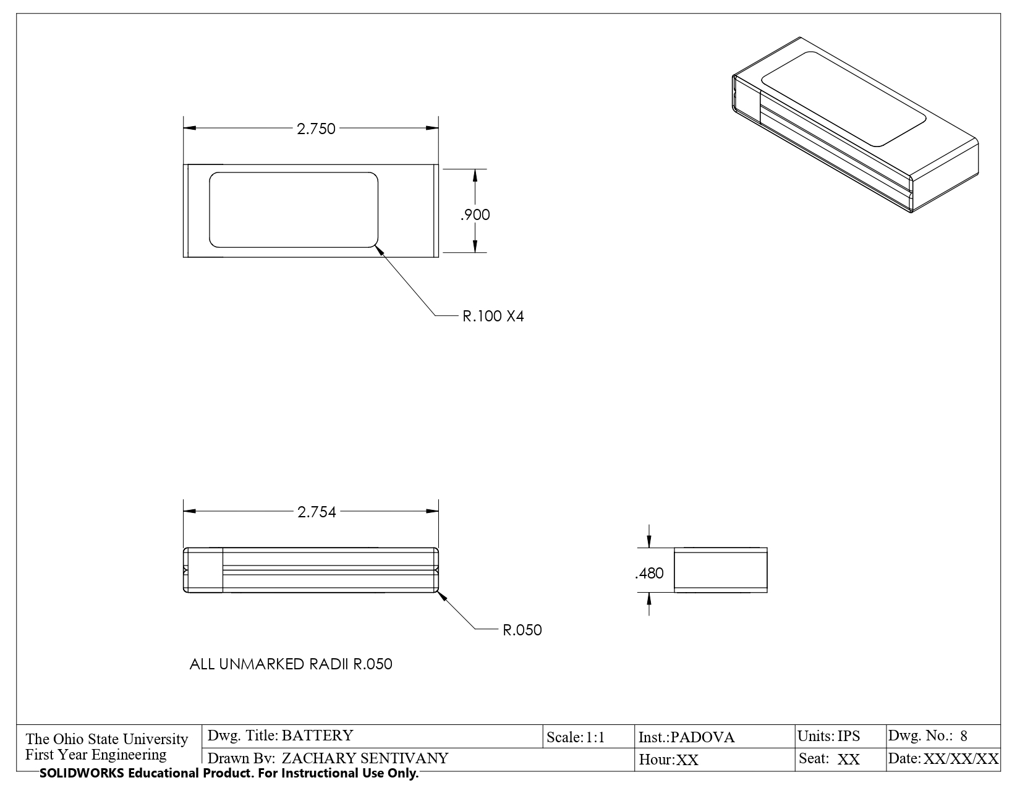

Figure 27. Battery Unit

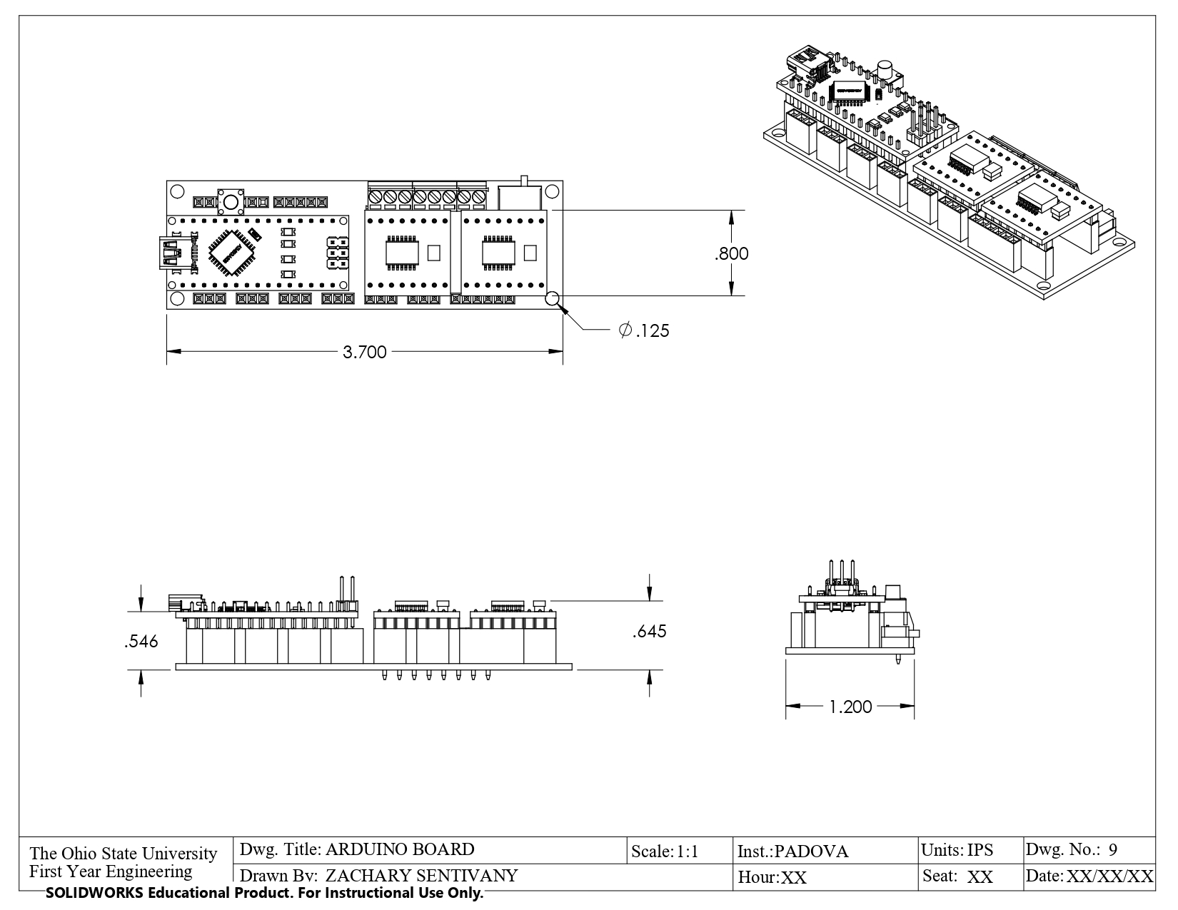

Figure 28. Arduino Board

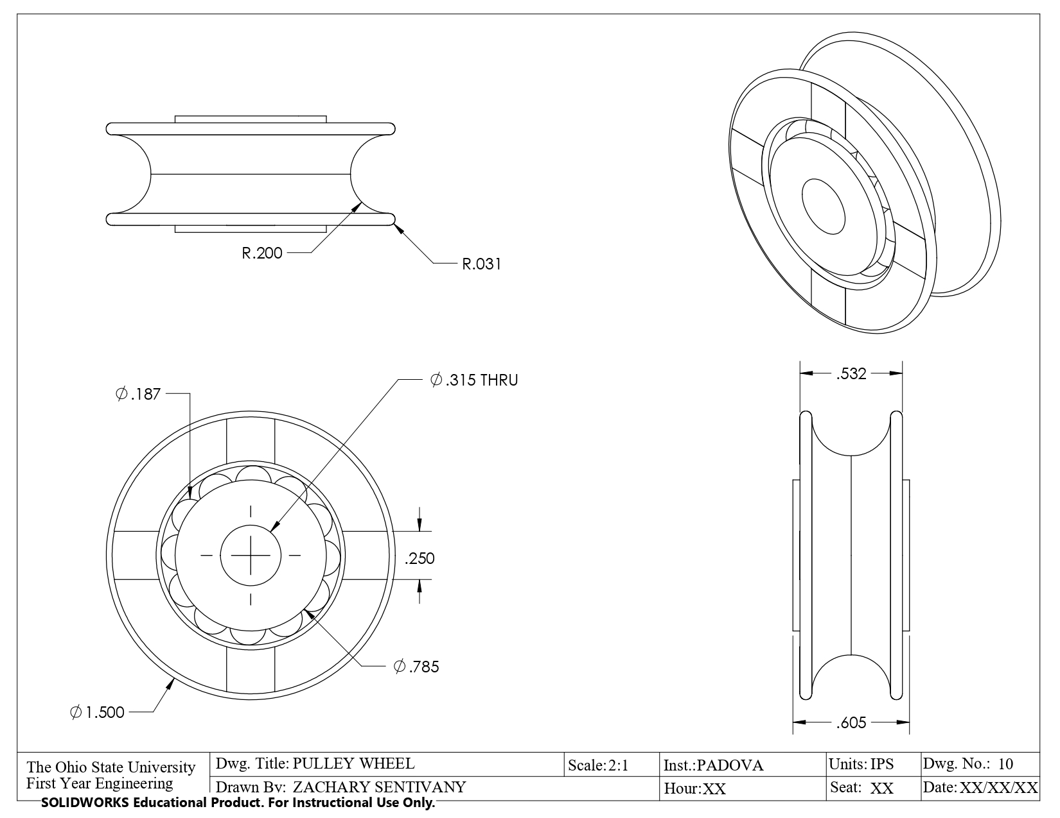

Figure 29. Pulley Wheel

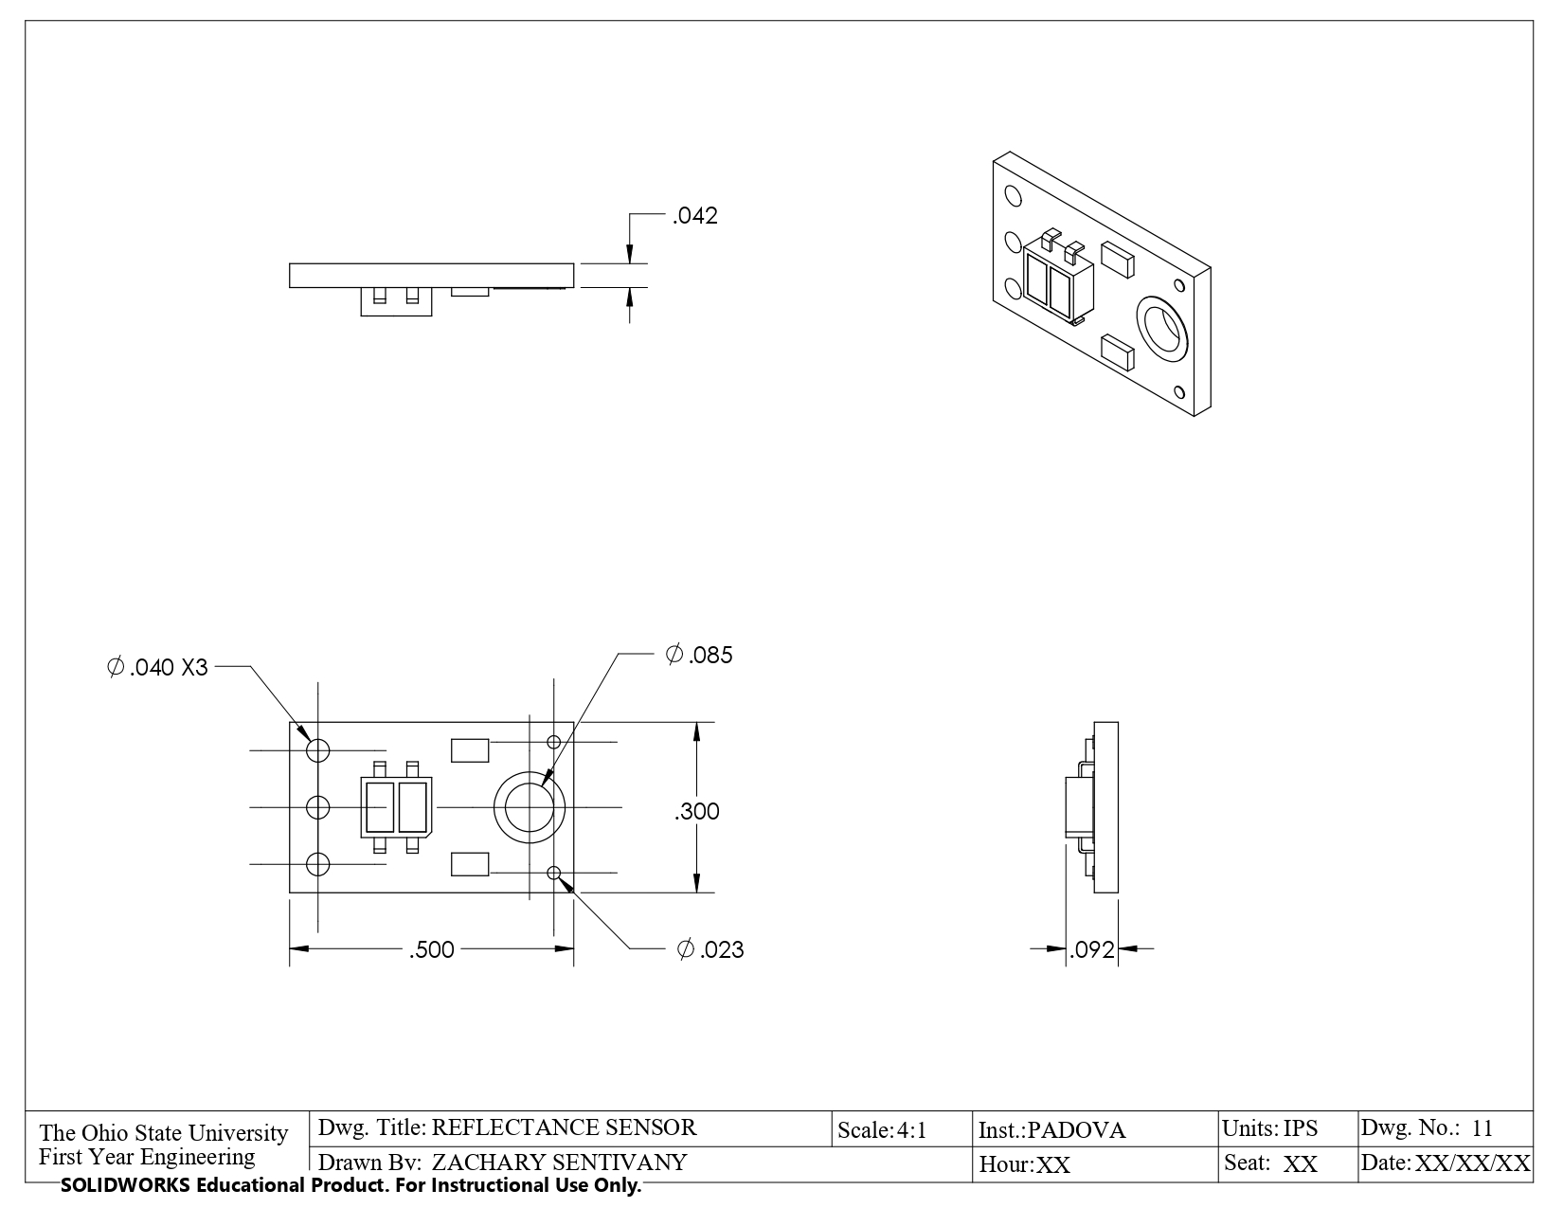

Figure 30. Reflectance Sensor

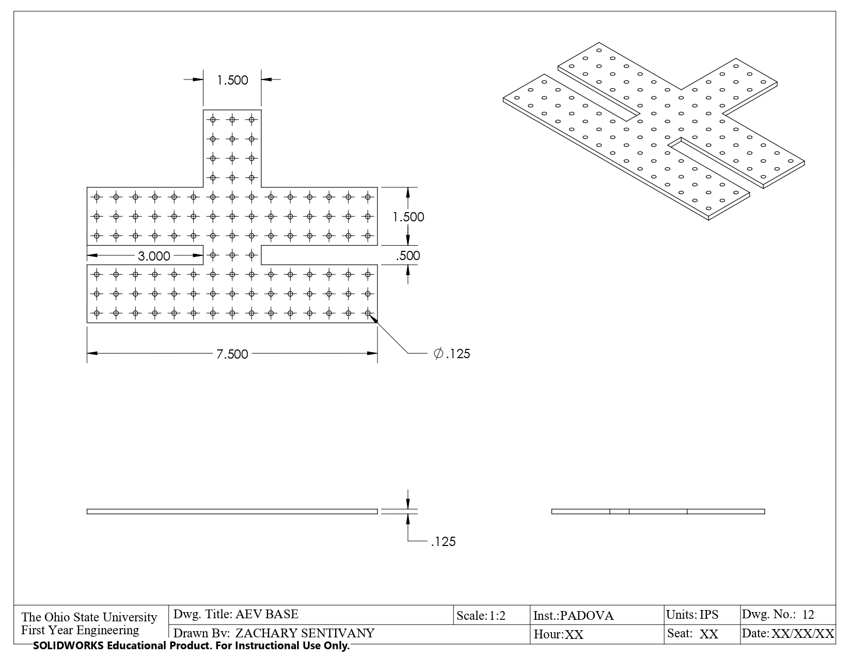

Figure 31. AEV Base/Main Chassis

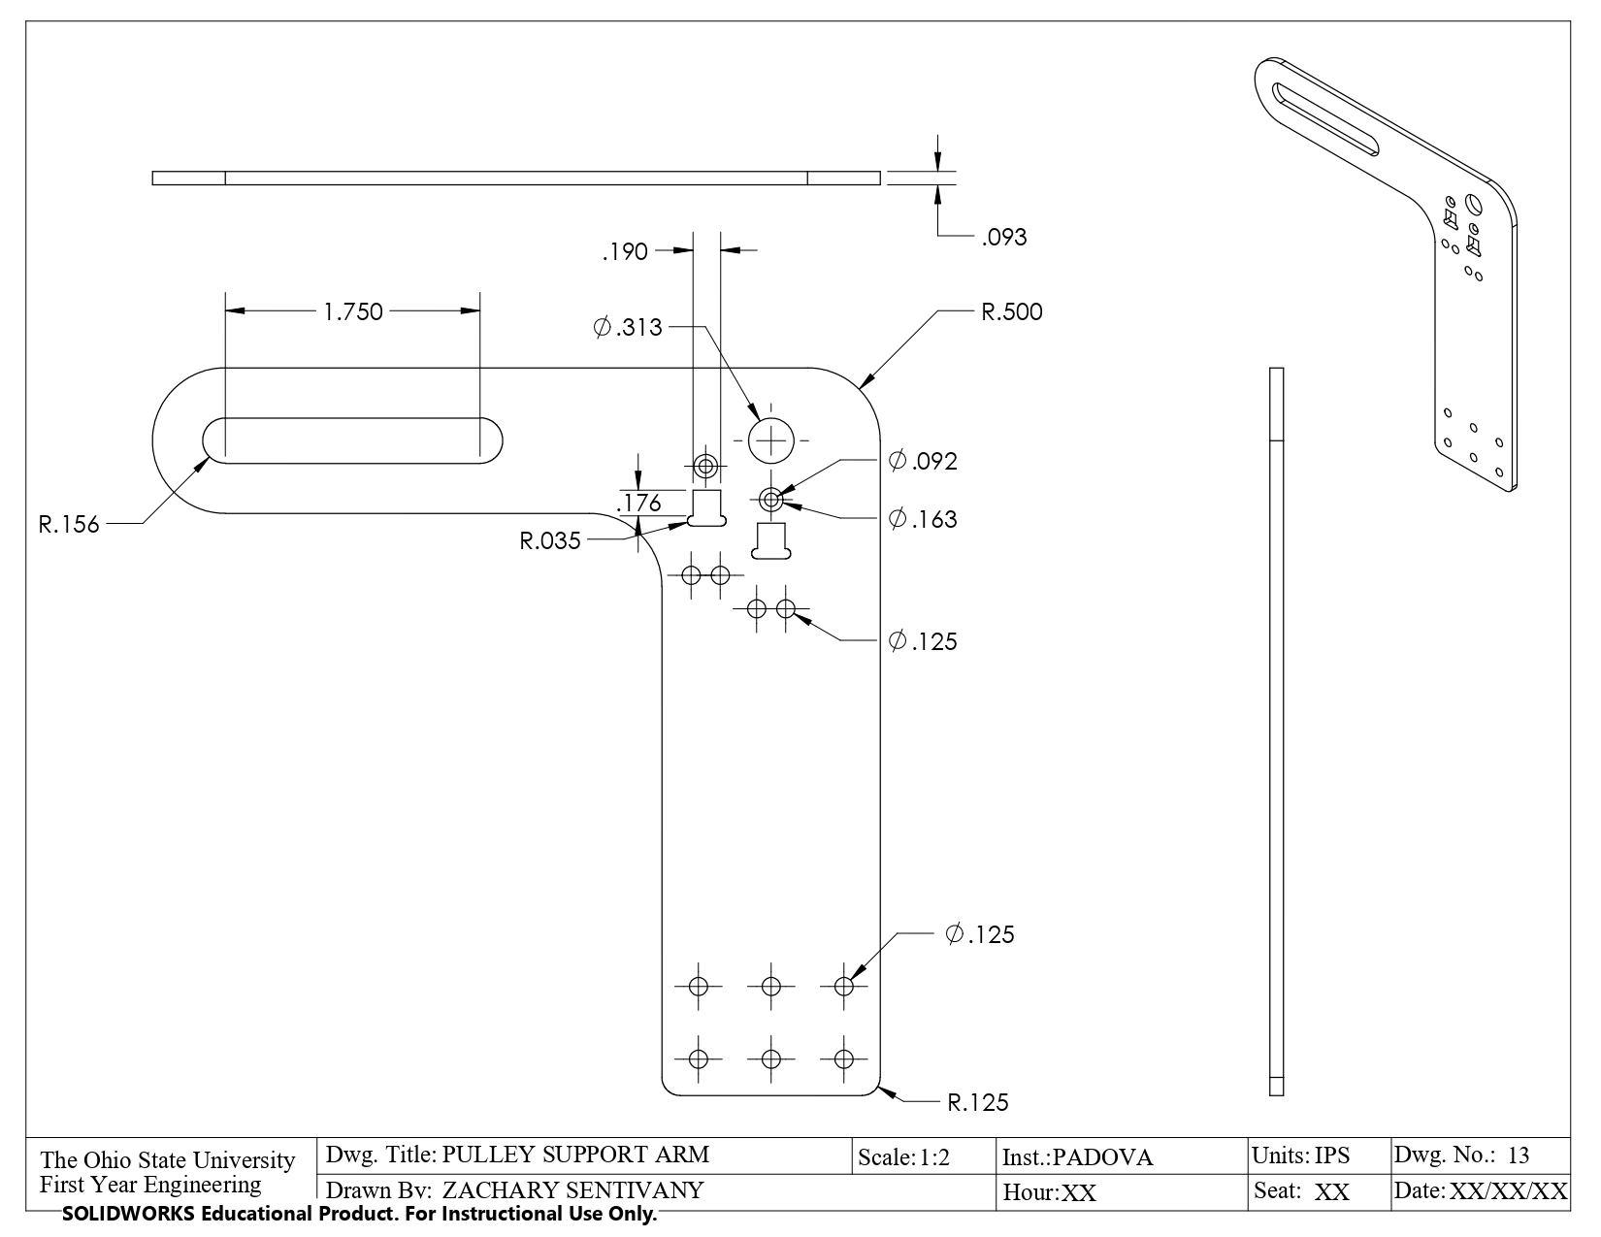

Figure 32. Pulley Support Arm



Figure 33. Concept AEV

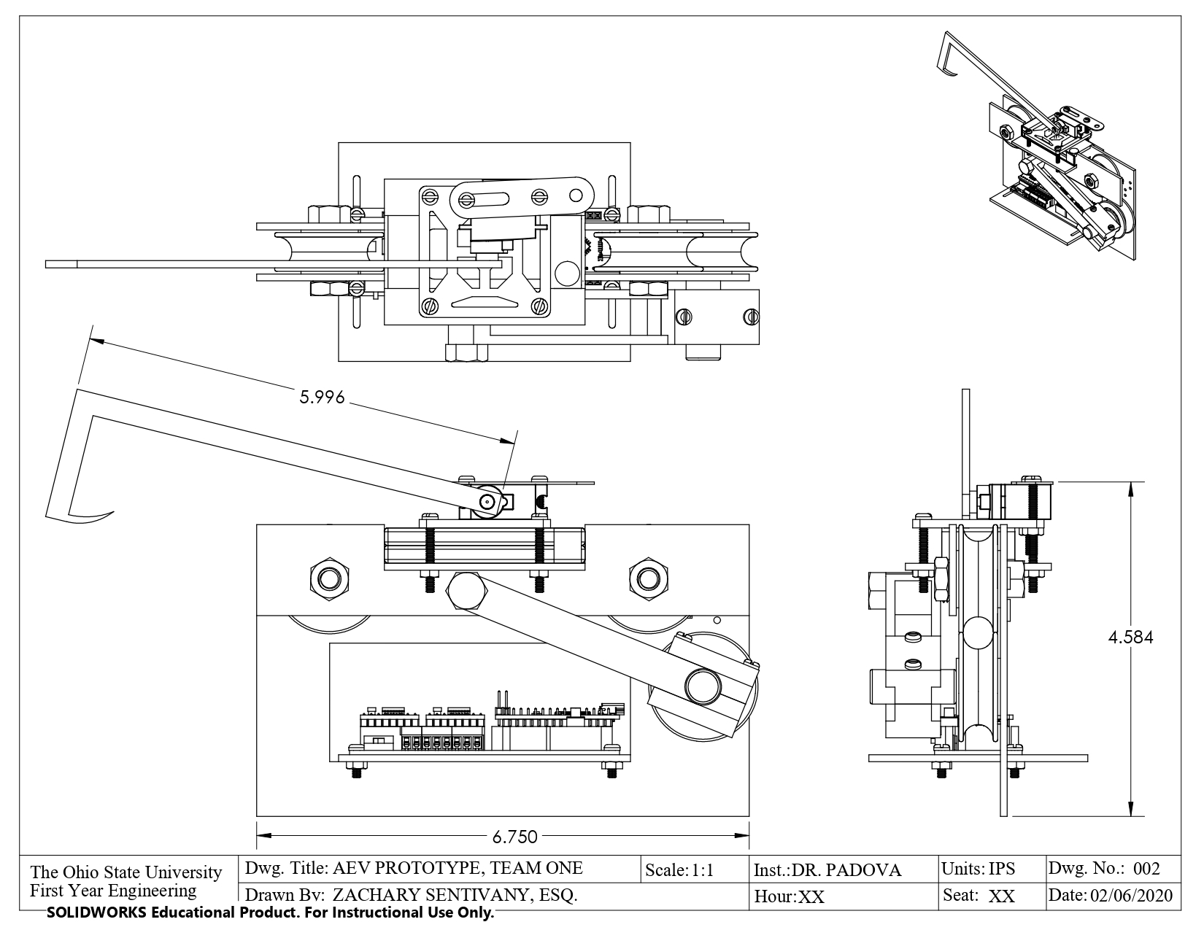

Figure 34. Concept AEV isometric

**Excess Energy Charts**

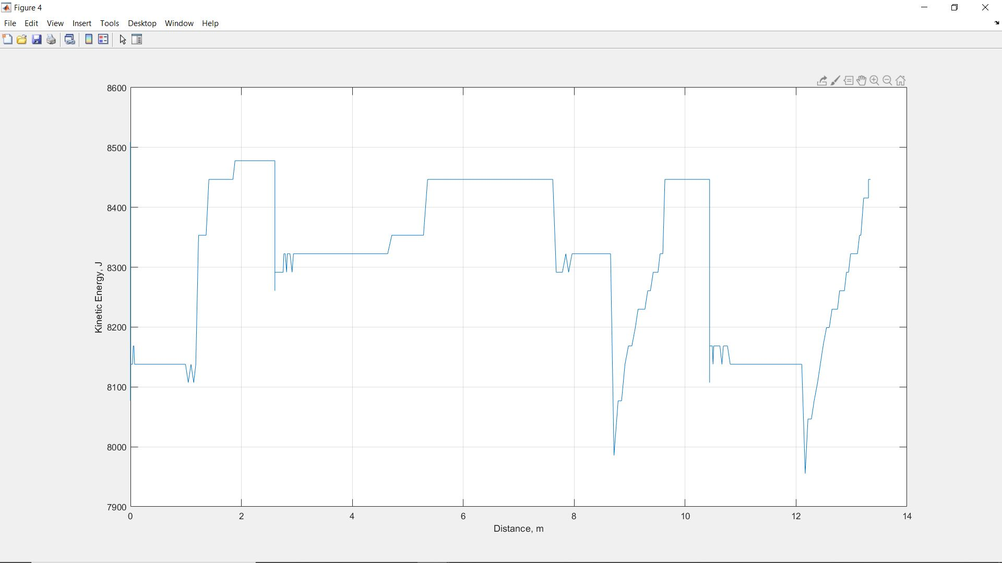

Figure 21. Kinetic Energy Versus Distance, Pink AEV, Half Run

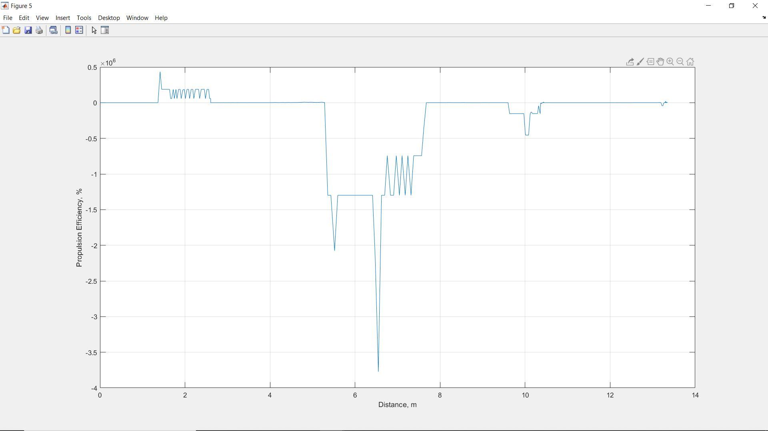

Figure 23. Propulsion Efficiency Versus Distance, Pink AEV, Half Run

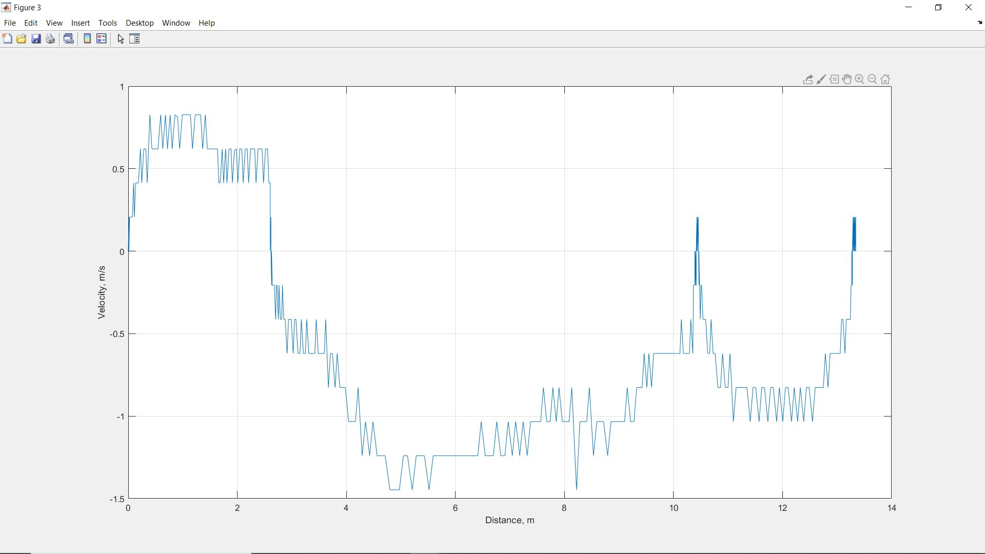

Figure 24. Velocity Versus Distance, Pink AEV, Half Run

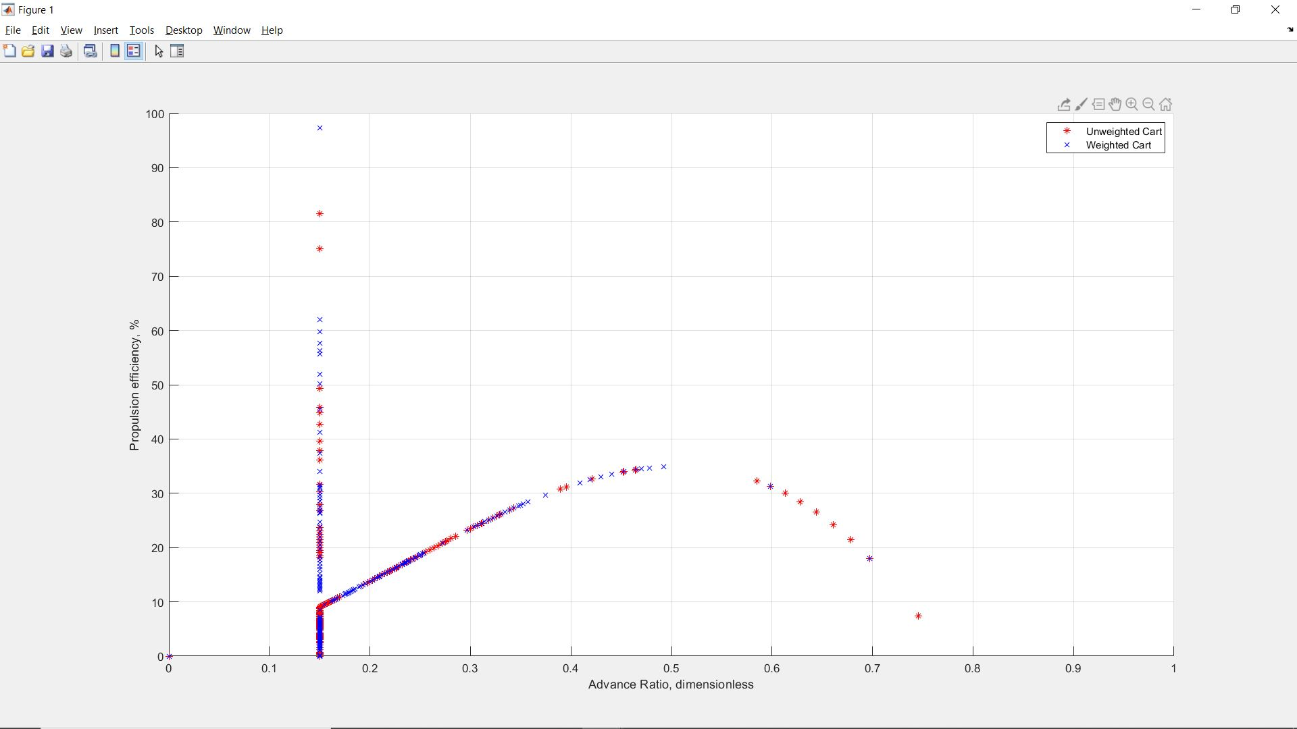

Figure 26. Propulsion Efficiency Versus Advance Ratio, Weight Comparison View, Full Run

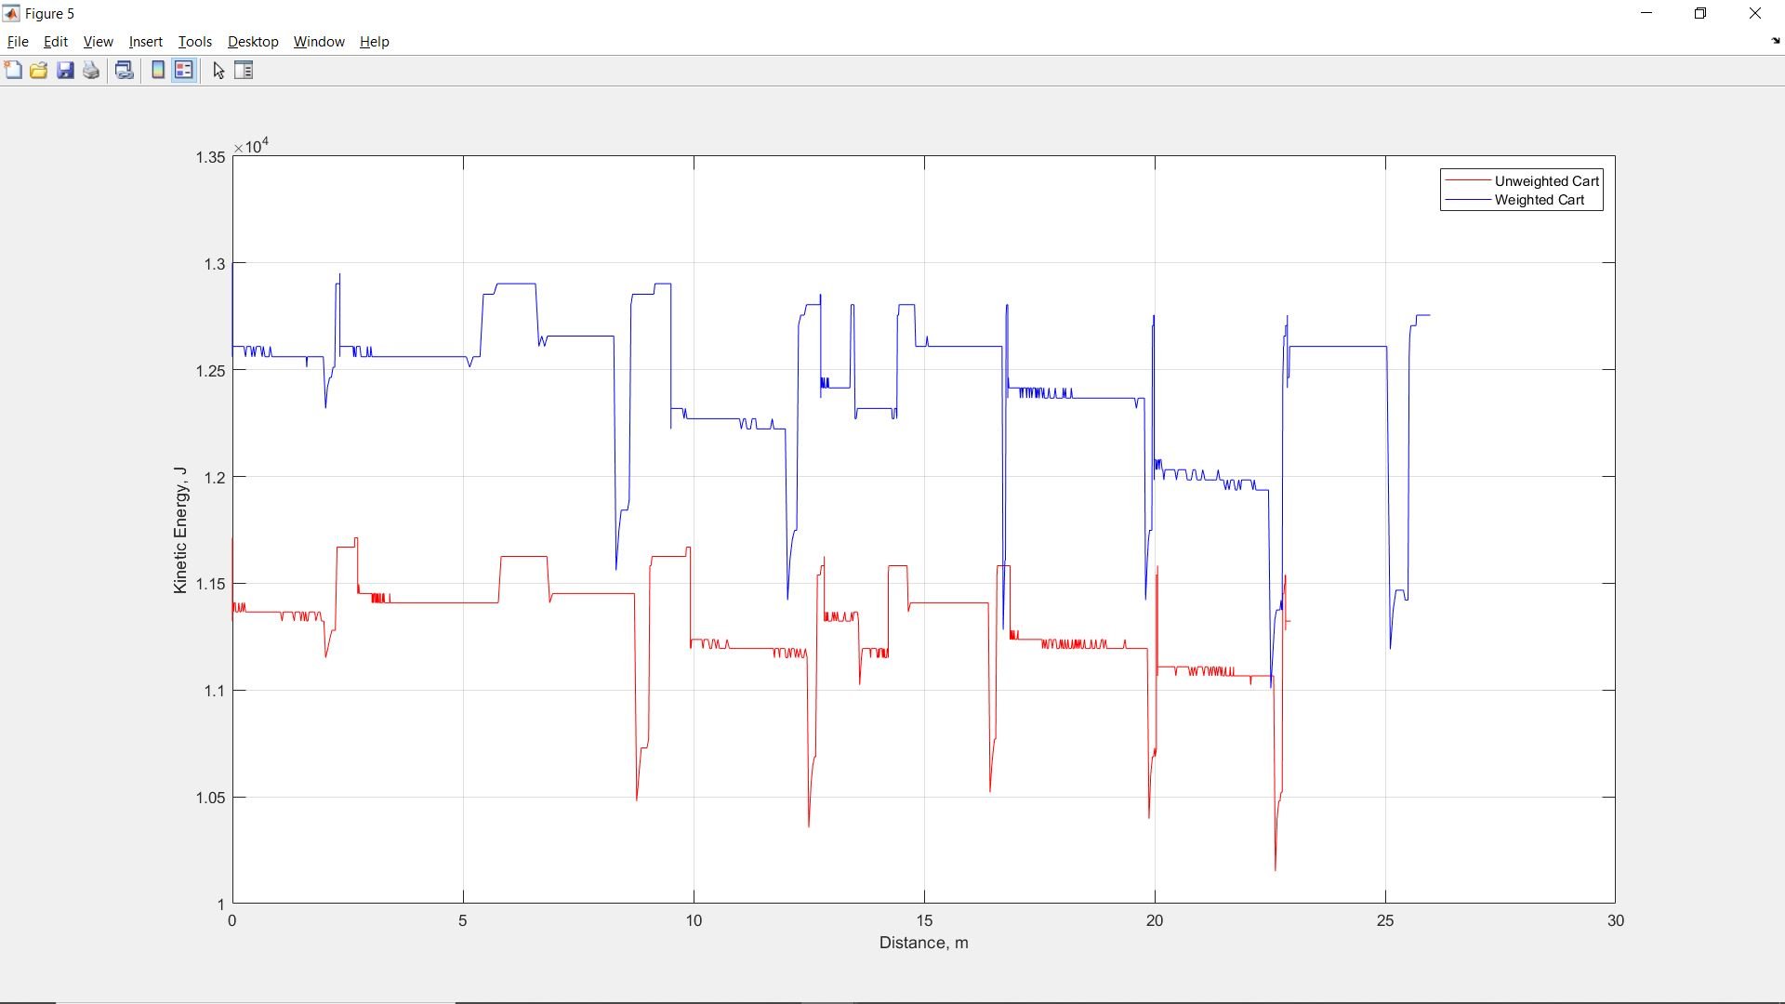

Figure 27. Kinetic Energy Versus Distance, Weight Comparison View, Full Run

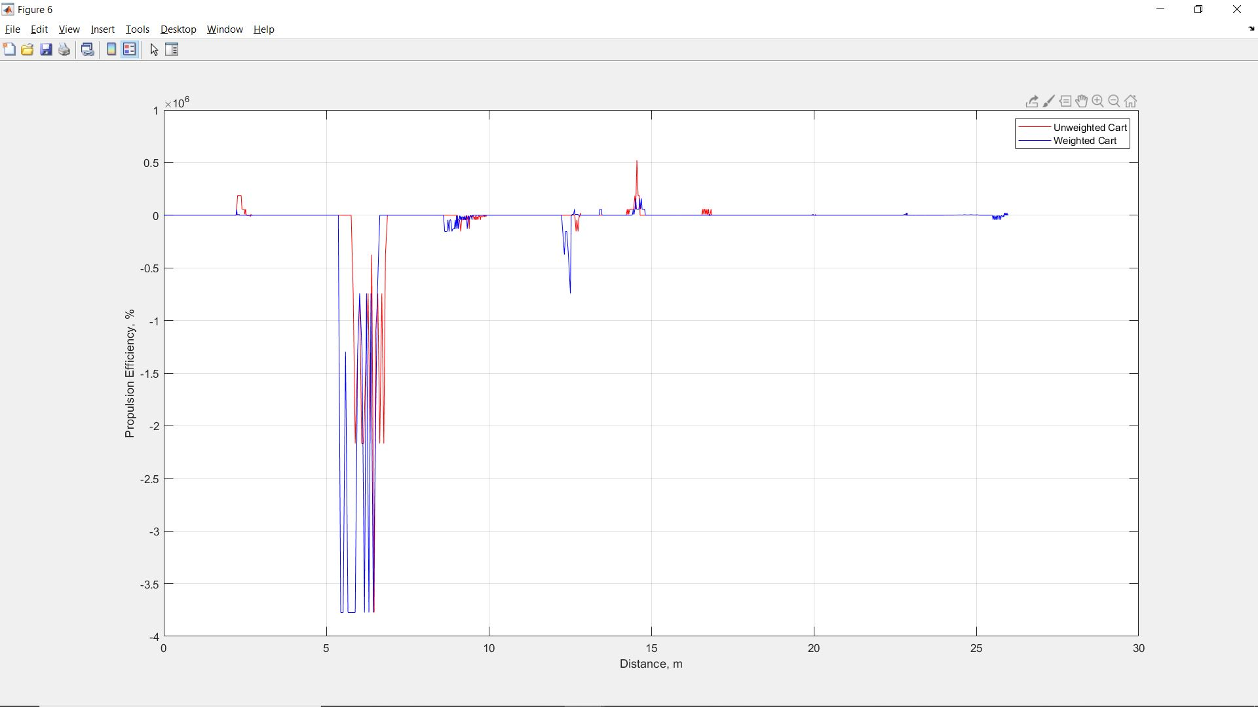

Figure 29. Propulsion Efficiency Versus Distance, Weight Comparison View, Full Run

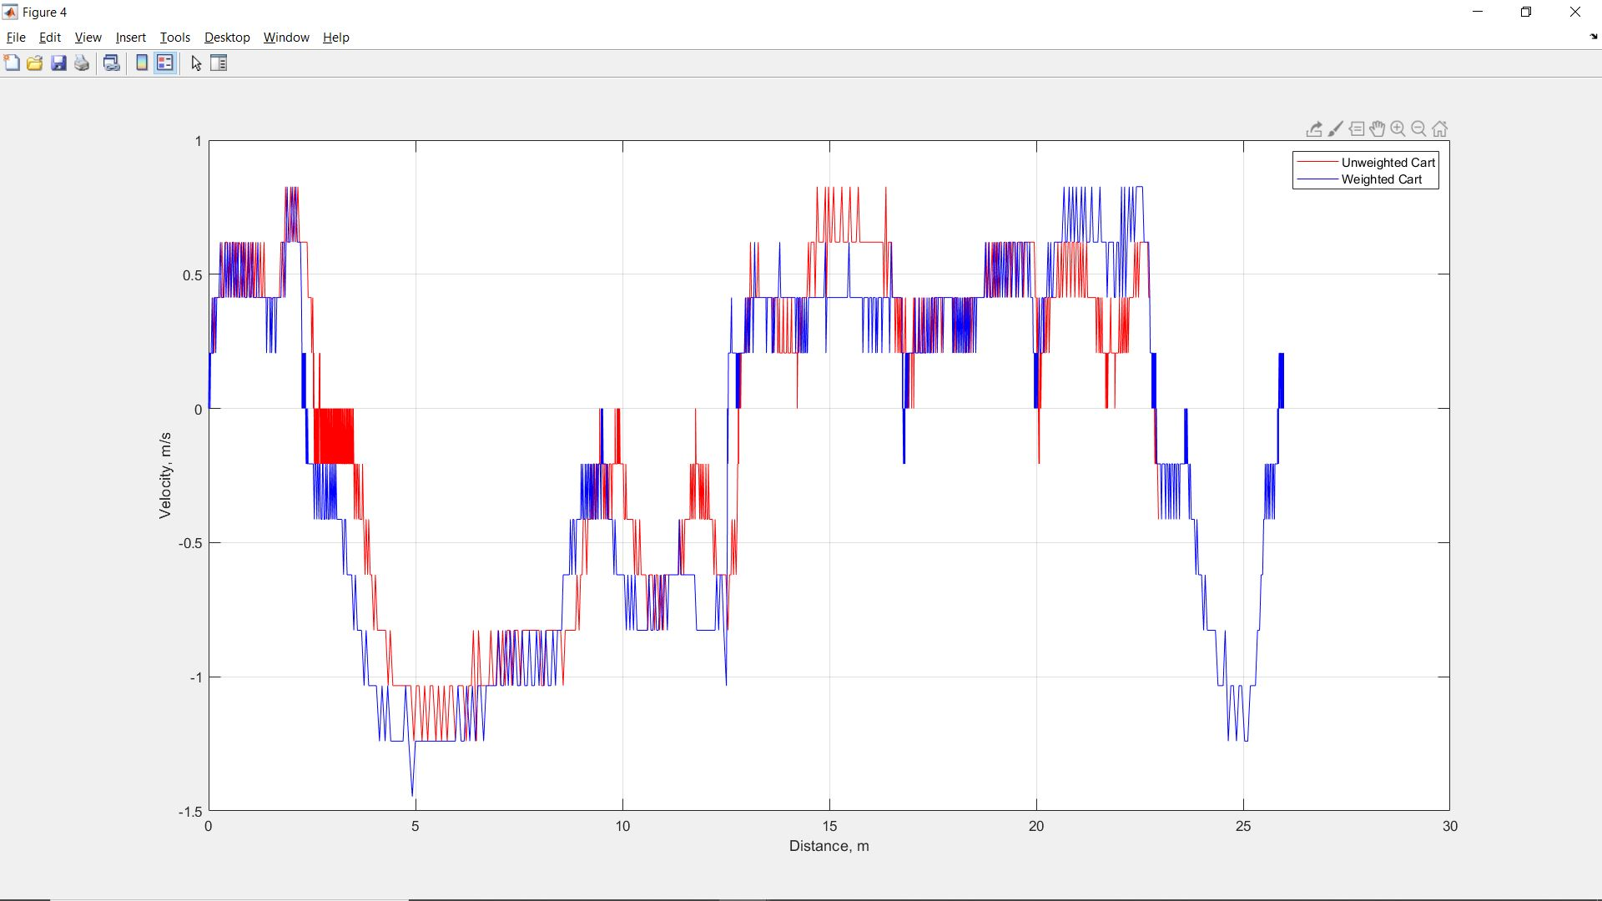

Figure 30. Velocity Versus Distance, Weight Comparison View, Full Run

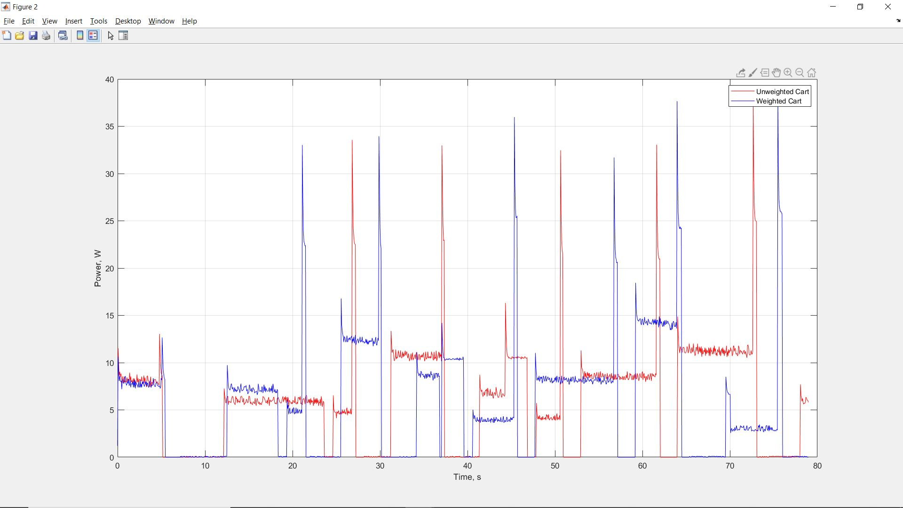

Figure 31. Power Versus Time, Weight Comparison View, Full Run